|  |
| --- |
| AWS Logo - LogoDix |
| AWS Cloud FoundationsModules 1-6Derek Liu |
| Periods 0,3,4  Mr. Mason & Mr. Hansen  CCNP Lab 8 |

**AWS Cloud Foundations Academy***Derek Liu*

Purpose

This isn’t necessarily a lab but rather working through the AWS Cloud Foundations Academy curriculum with the goal of obtaining an AWS Cloud Foundations certification. This lab will contain modules 1 through 6 (another writeup will contain modules 7-10).

Background Information

The Amazon Web Services Cloud Foundations Certifications is an entry-level certification. It is used to represent basic understanding of the AWS cloud. In this lab, we go through a curriculum meant to prepare students to take the AWS Cloud Foundations Certification test. In order to obtain the certification, students must pass a multiple-choice exam that covers information on AWS Cloud infrastructure, security, billing, and core AWS services. The Cloud Foundations Certificate is a prerequisite for many other AWS certifications.

Module 1: Cloud Concepts

Cloud computing is the on-demand delivery of compute power, database, storage, application, and other IT resources. Usually pay as you go pricing. Cloud offers infrastructure solutions through software. IaaS – infrastructure as a service (highly flexible). PaaS – platform as a service. SaaS – software as a service (end user stuff).

Advantages of cloud computing:

1. Trade capital expenses for variable expenses
2. Massive economies of scale (lower variable cost)
3. Not guessing capacity
4. Increase speed and agility.
5. Reduced spending on running and maintaining data centers
6. Go global in minutes

Intro to AWS (Amazon web services). Web services are pieces of software that makes itself available over the internet. Uses XML or JSON for response or request of API. AWS is a web-based service with cloud-based products. Examples:

* Amazon EC2 for complete control over AWS compute resources and infrastructure.
* AWS Lambda for running code and not manage or provision servers.
* AWS Elastic Beanstalk allows provisioning of a service that manages and scales web applications automatically.
* Amazon Lightsail is a cloud platform for launching simple web applications
* AWS Batch for running a lot of batch workloads
* AWS Outposts for running AWS infrastructure on on-premise infrastructure.
* Amazon Elastic Container Services or implementing a containers
* VMware Cloud on AWS when you have on-premise server you want to migrate to AW

Ways to interact with AWS:

* AWS Management Console: easy to use graphical interface.
* AWS CLI: access to services by discrete commands or scripts
* Software Development Kits: access services directly from code.

Moving to cloud is a lot of shifting. Must align people, process, and technology. AWS CAF (cloud adoption framework) provides guidance for migrating to cloud.

Module 2: Cloud Economics and Billing

Three main categories of cost with AWS; computing, storage, and data transfer. No cost for inbound data transfer and data transfer in between services in the same region is free. AWS charges on a monthly basis and charges outbound traffic. All services are available on demand and no upfront payments and no long term contracts. Volume based discounts (e.g. Amazon S3 pay less per gigabyte the more you use). AWS is able to lower prices continuously due to economies of scale. Higher performing resources replace current ones at no extra cost. AWS free tier for 1yr for new customers. Comes with free Amazon EC2 T2 micro instances for 1yr. Some services are offered with no extra charge:

* Amazon VPC
* Elastic Beanstalk
* Auto Scaling
* AWS CloudFormation
* AWS Identity and Access Management (IAM)

TCO (total cost of ownership) is the financial estimate to help identify direct and indirect costs of a system. Used to compare on premise vs cloud. TCO considers server costs, storage costs, network costs, and IT labor costs. AWS Pricing Calculator can be used to estimate monthly costs and find opportunities to reduce cost.

AWS Organizations for managing multiple AWS accounts. Control access with AWS IAM. Service control policies enable you to allow or deny access to AWS services for individuals. Steps to setting up AWS Organizations:

1. Create organization
2. Create organizational units
3. Create service control policies
4. Test restrictions

Can be access with AWS management console, AWS CLI, SDKs, and HTTPS Query API.

AWS Billing and Cost Management is service used to pay AWS bills, monitor usage, and budget expenditures. AWS Cost and Usage Report Tool, part of the AWS Billing, and Cost Management services, is used to identify opportunities for optimization by understanding cost and usage data trends.

Exploring the AWS Billing Dashboard:

* Cost explorer for current cost and forecasted costs. Can be used to create reports.
* AWS Budgets can be used to trigger alerts if usage goes over budget.

AWS Technical support plans. Support helps support customers that help them succeed. Includes customers just experimenting with AWS.

* Technical Account Manager: proactive guidance (only available with enterprise support plan)
* AWS Trusted Advisors: best practices
* AWS Support Concierge: Account assistance.

Different support plans offered by AWS:

* Basic support: resource center access, service health dashboard, product FAQ, discussion forums, and support for health checks
* Developer support: support for early development of AWS
* Business support: costumers that run production workloads.
* Enterprise support: customers that run business and mission-critical workloads.

Different case severity and response times of AWS support (you don’t get this stuff with basic):

* Critical: business is at risk. Critical functions unavailable.
* Urgent: business significantly impact. Important functions unavailable.
* High: important functions impaired.
* Normal: non-critical functions behaving abnormally or time-sensitive development questions
* Low: general development questions or request a feature.

Module 3: AWS Global Infrastructure Overview

AWS Global Infrastructure is designed and built to deliver flexible, reliable, scalable, and secure cloud computing environments with high quality global network performance. AWS Regions available near me include Oregon, N. California, and GovCloud (US-west). Elastic and scalable. Fault tolerant. High level of availability.

AWS Region is a geographical area with availability zones which contain data centers. Data stored in one region is not replicated in another region (unless you manually do it). AWS in China only provides access to Beijing and Ningxia regions. GovCloud is for US government to move sensitive workloads into the cloud.

When selecting which region to use: data governance, proximity to customers, services available in the region, and costs.

AWS data centers are designed for security and failure in mind. Data centers locations are not disclosed.

Amazon CloudFront is a content delivery network used to distribute content to end-users in order to reduce latency. Amazon route 53 is a domain name system (DNS). Amazon points of presence are used to reduce latency and are available in most major cities.

AWS Foundational services infrastructure can be broke down into regions, availability zones, and edge locations.

Most common used AWS categories of services include:

* Compute: Amazon EC2, Amazon EC2 auto-scaling, Amazon ECS, Amazon EC2 container registry, Amazon Elastic Beanstalk, AWS Lambda, Amazon EKS, AWS Fargate.
* Cost management: AWS Cost and Usage Report, AWS Budgets, AWS Cost Explorer
* Database: Amazon Relational Database Service, Amazon Aurora, Amazon Redshift, Amazon DynamoDB
* Management and governance: AWS Management Console, AWS Config, AWS CloudWatch, AWS Autoscaling, AWS CLI, AWS Trusted Advisor, AWS Well-Architected Tool, AWS CloudTrail
* Network and Content delivery: Amazon VPC, Elastic Load Balancing, Amazon CloudFront, AWS Transit Gateway, Amazon Route 53, AWS Direct Connect, AWS VPN
* Security, Identity, and Compliance: AWS IAM, AWS Organizations, Amazon Cognito, AWS Artifact, AWS Key Management Service, AWS Shield
* Storage: Amazon simple storage service (Amazon S3), Amazon Elastic Block Store (Amazon EBS), Amazon Elastic File System (Amazon EFS), and Amazon Simple Storage Service Glacier.

Module 4: AWS Cloud Security

Security is a shared responsibility between AWS and the customer. AWS security model shows which part of security is handled by AWS and which parts need to be handled by the customer. AWS responsibility for the security of the cloud. Customers must secure their data. AWS provides tools to help customers secure data.

Examples of services managed by the customer:

* Amazon EC2
* Amazon elastic block store (EBS)
* Amazon Virtual Private Cloud (VPC)

Examples of services managed by AWS:

* AWS Lambda
* Amazon Relational Database Service
* AWS Elastic Beanstalk

IaaS usually puts more responsibility on the customer while PaaS puts more responsibility on AWS. SaaS puts all responsibility on AWS.

AWS Identity and Access Management (IAM). Device users and the things they have access to. A global service. IAM is a no-cost AWS account feature.

IAM User is a person or application that can authenticate with an AWS account

IAM group is a collection of IAM users that are granted identical authorization

IAM Policy is the document that defines access to one or more services

* Two types of policies. Identity and resources based policies.

IAM Role is a useful mechanism for granting temporary services (similar to sudo command)

Different types of access can be granted. Programmatic access can be authenticated with access key and provides AWS CLI access. AWS management console access can be authenticated with IAM username and password. For increased security, you can enable MFA (multi factor authentication).

Authorization is deciding what actions are allowed by a user after they are authenticated. By default, they can’t do anything. Must specifically grant permissions. Best practice of principle of least privilege.

When you first create a new AWS account you get a root account. Root account has full access to all resources. AWS suggests to not use this for day-to-day interactions. Use least-privilege. To stop using the root account, create an Identity and access management user with AWS management console. Enable MFA and create a different password. Create a group and attach a policy. Disable and remove root account access keys. AWS CloudTrail is a service that logs all API requests to resources in your account. Helps with security and forensic investigations. Enable billing reports.

AWS Organizations can be used to manage multiple AWS accounts. Security features include group AW accounts into organizational units (OU) and attach different polices to each. Integration and support for IAM. Use service and control policies to establish control over AWS services and AWS actions that each AWS account can access. Service control policies (SCP) offer centralized control over accounts and limit permissions. SCP is similar to IAM but an SCP never rants permission but specifies the maximum permissions for an organization.

AWS Key Management Services (KMS) allows you to create and manage encryption keys. Helps control the use of encryption across AWS services. Integrates with CloudTrail to log all key usage.

Amazon Cognito adds user sign-up and access control to your web and mobile application via SAML.

AWS shield is a managed distributed DDoS protection service. Safeguards applications on AWS and used to minimize application downtime and latency. Available to all customers.

Encryption encodes data with a secret key. AWS Supports encryption of data at rest (data stores physically on a disk or tape. You can encrypt data stored in any services that is supported by AWS KMS. Data in transit refers to data moving across the network. Uses TLS 1.2 (formerly SSL) as encryption. AWS Certificate Manager provides a way to manage, deploy, and renew TLS or SSL certificates. HTTPS creates a secure tunnel. AWS services support data in transit encryption.

AWS engages with external certifying bodies. AWS provides security features and legal agreements that are designed to help support customers with common regulations and laws.

AWS Config is a service you can use to assess and audit the configuration of AWS resources. Keeps a history of AWS configurations,

AWS Artifact provides on-demand downloads of AWS security and compliance documents. Can be used to demonstrate security and compliance of AWS infrastructure to auditors with documents. Can be used to track AWS agreements such as Business Associate Agreement.

**Lab 1** **Introduction to AWS IAM**

Lab will:

* explore pre-created IAM users and groups.
* Inspect IAM policies as applied to the pre-created groups.
* Following a real-world scenario, adding users to groups with specific capabilities enabled
* Locating and using the IAM sign-in URL
* Experiment with the effects of policies on service access

Step 1: Click “start lab” and wait for the lab to load.

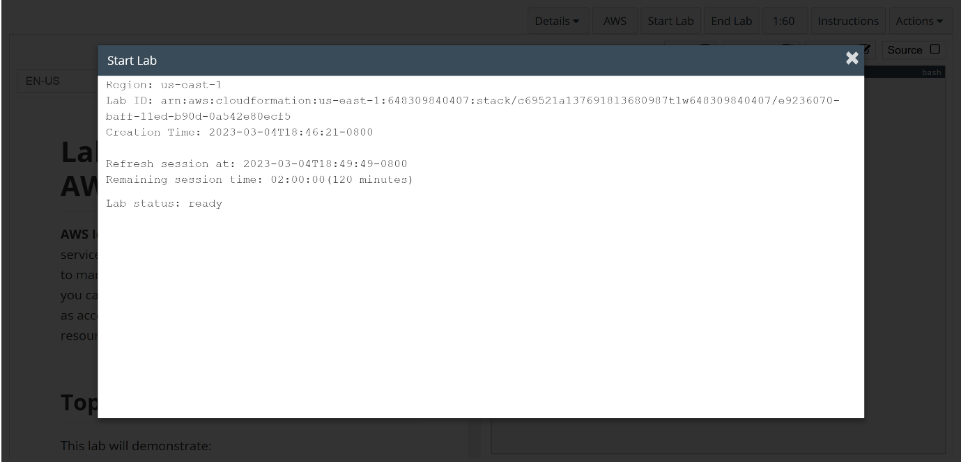

Step 2: Click “AWS”

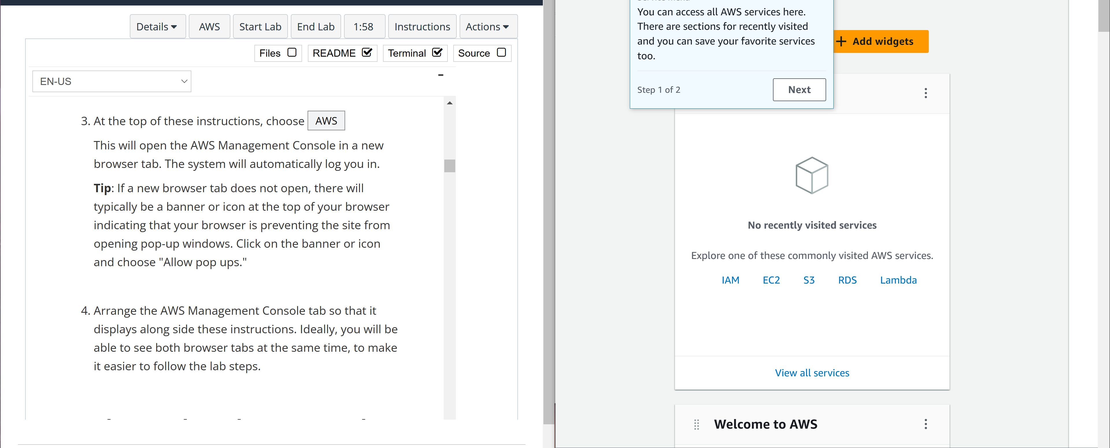

Step 3: in the AWS management console, go to services and select IAM.

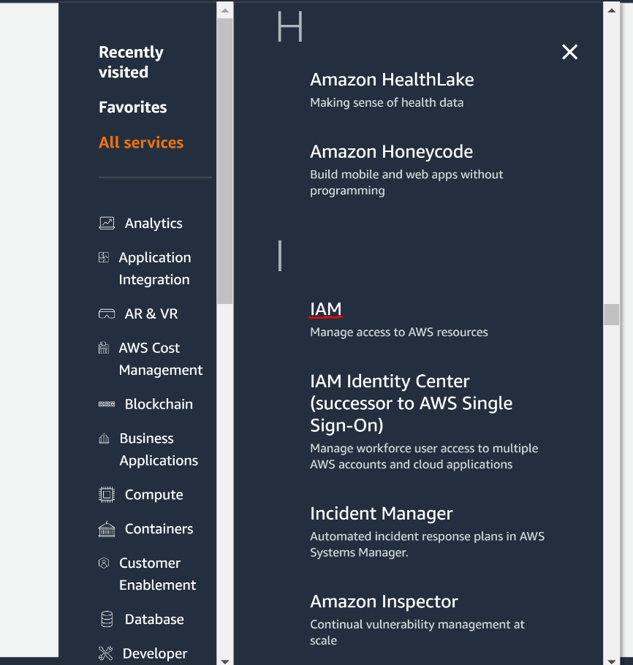

Step 4: Select “user groups”

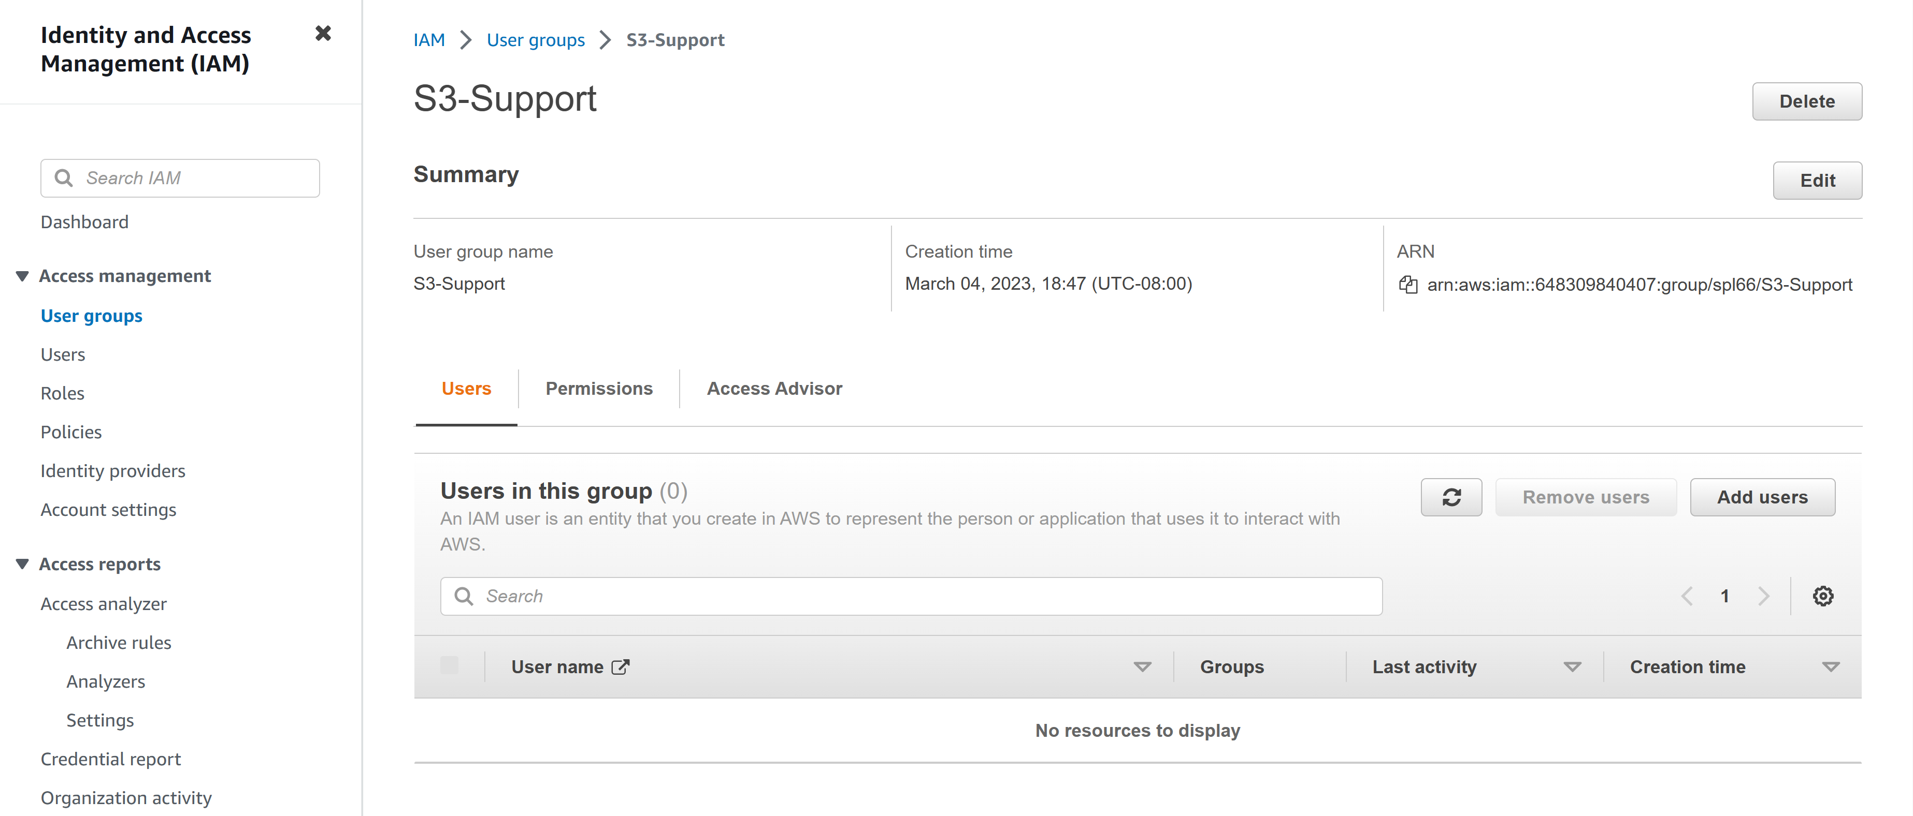

Step 5: select “add users”

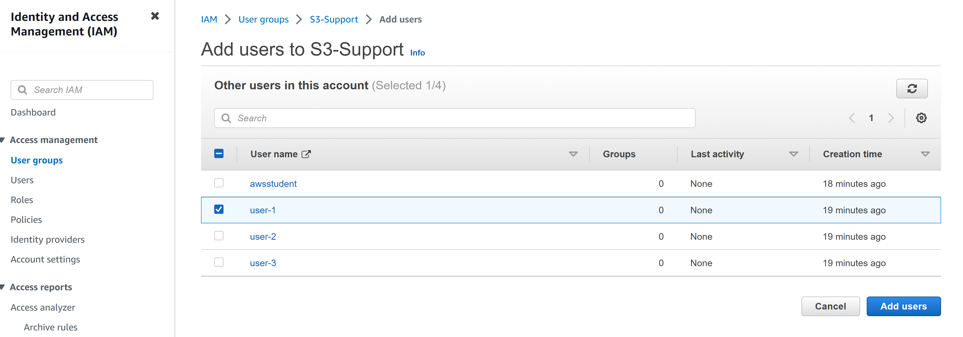

Step 6: add “user-2” to EC2-Support

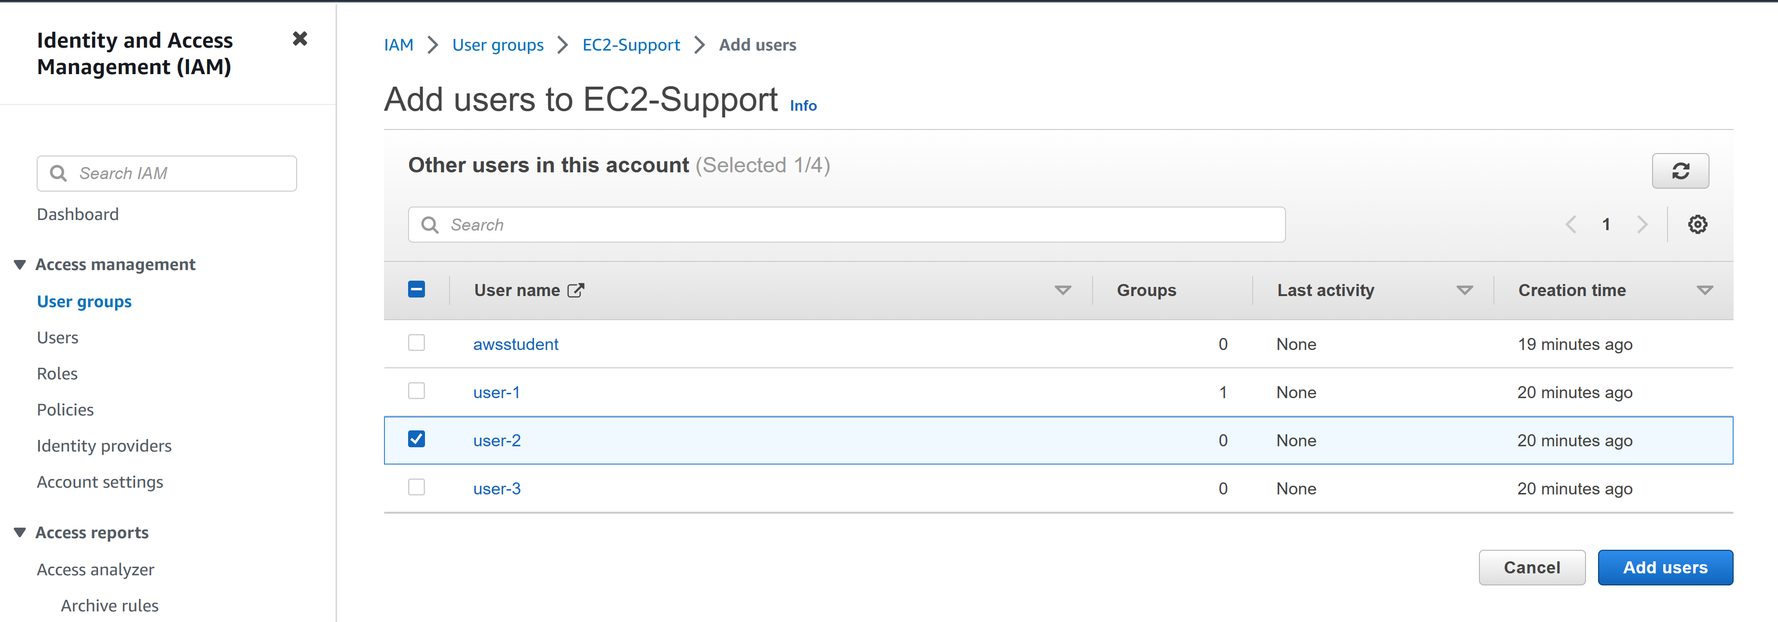

Step 7: add “user-3” to EC2-Admin

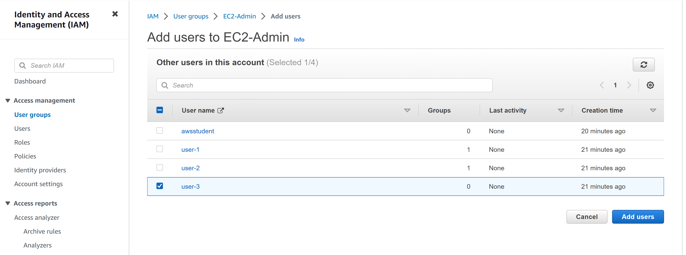

Step 8: go to the dashboard and find the management console link. Copy the link and open it in a new tab.

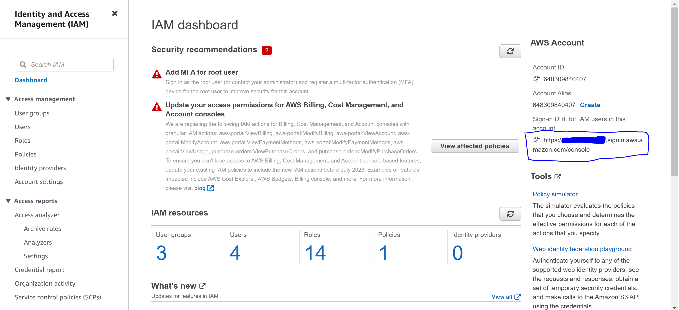

Log in with

User: user-1

Pass: Lab-Password1

Step 9: Go to “services” and “s3”. You should be able to open the bucket since you have permission.

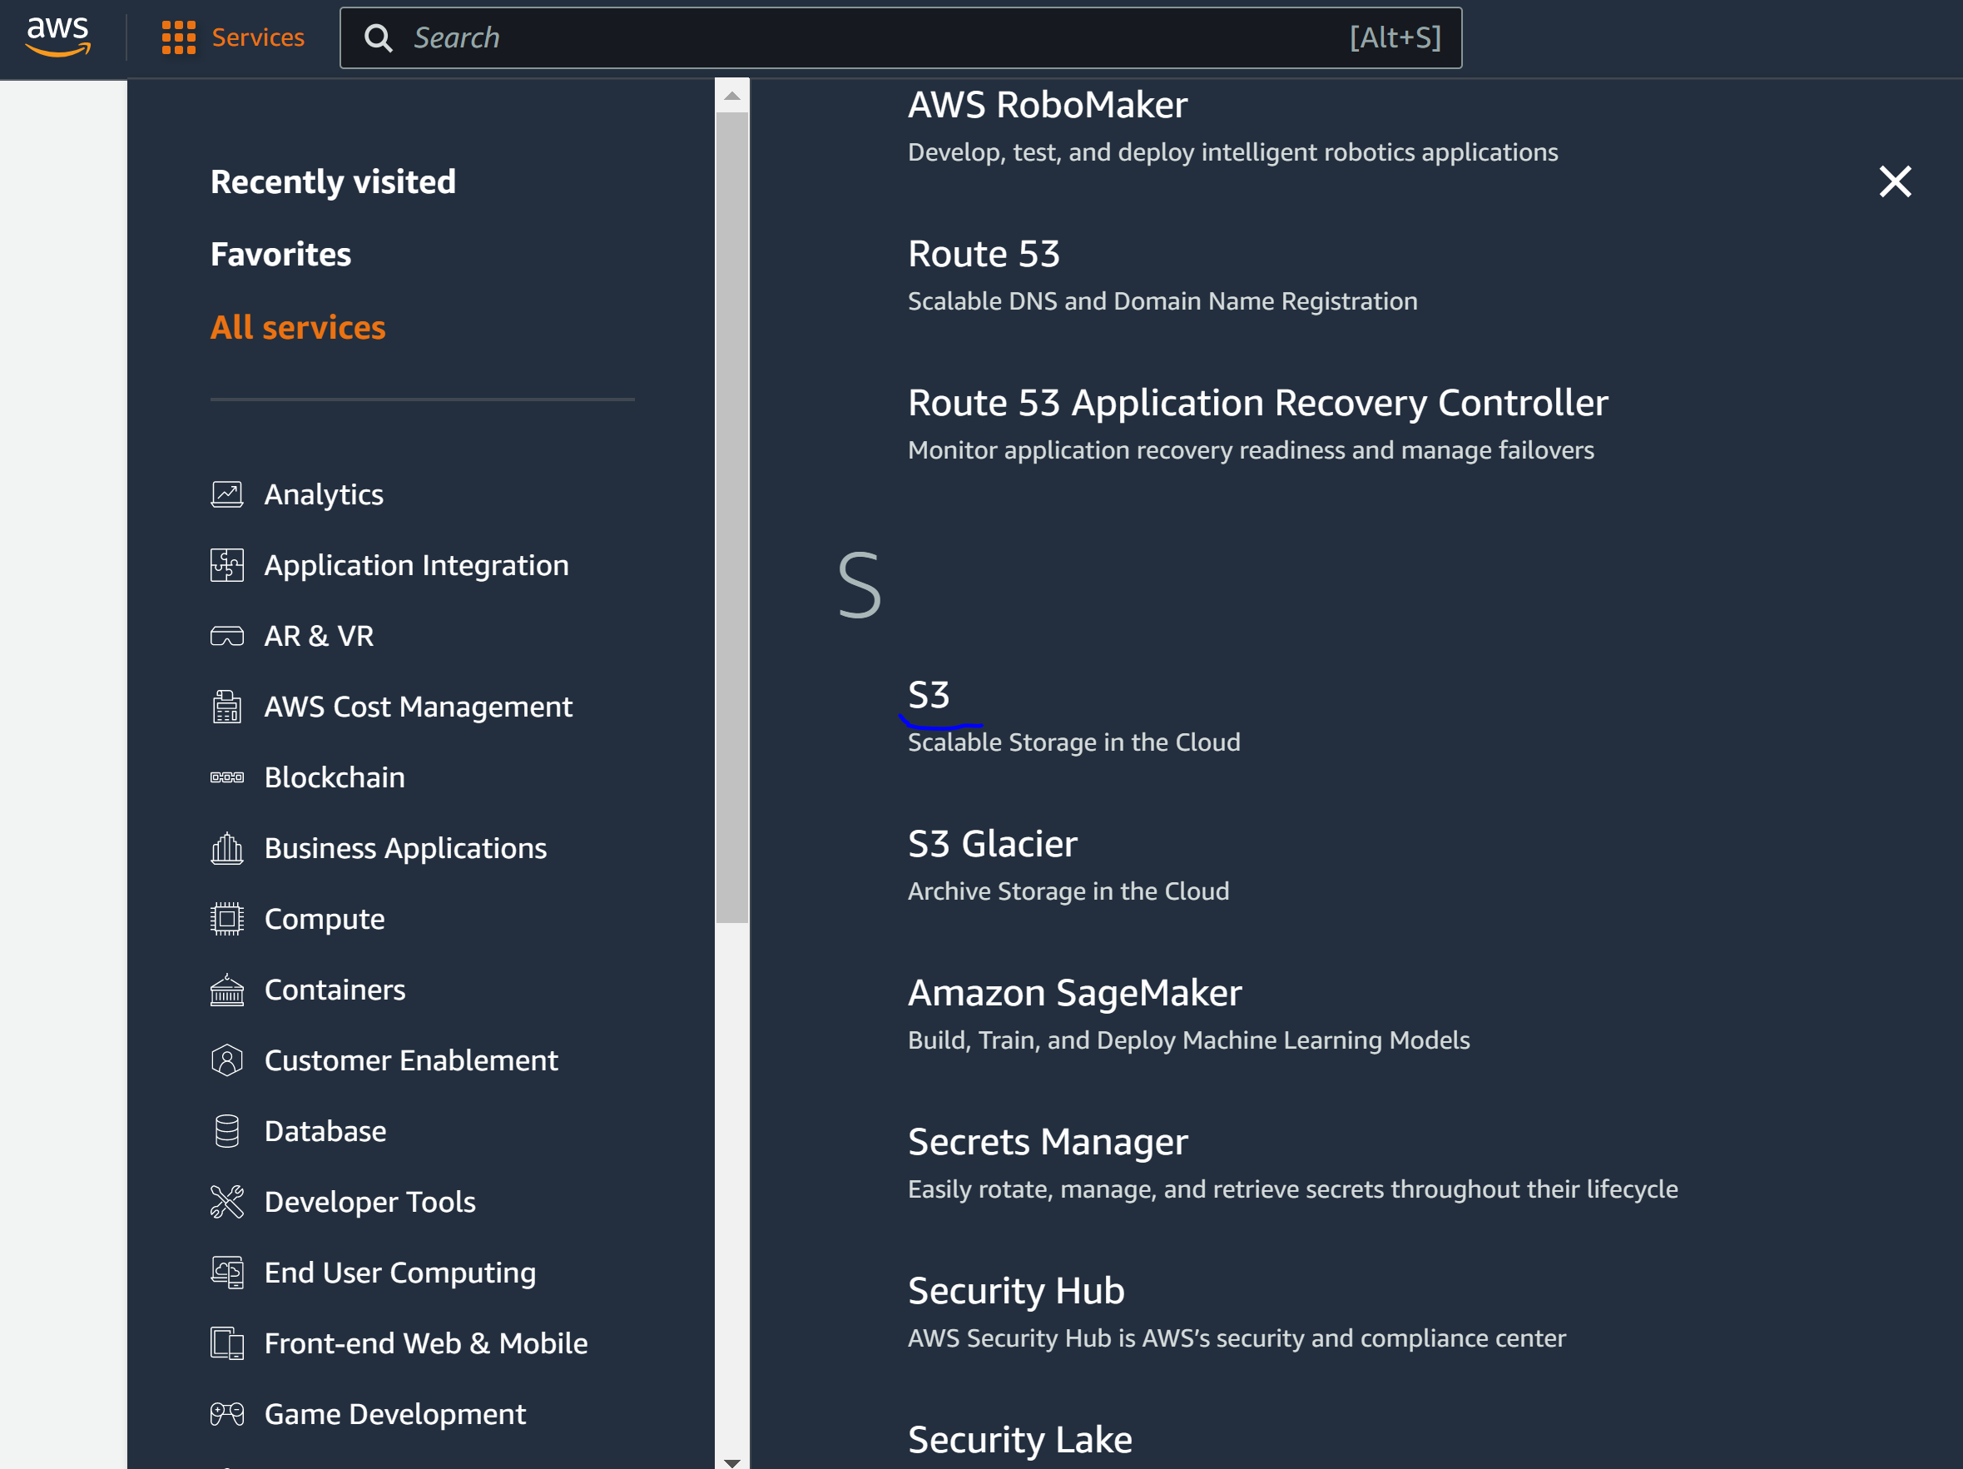

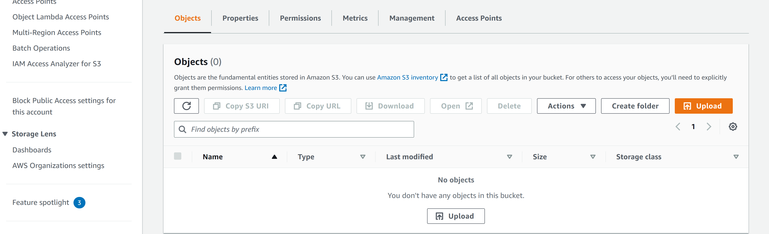

Step 10: Got to “services” and “ec2.” You shouldn’t have authorization.

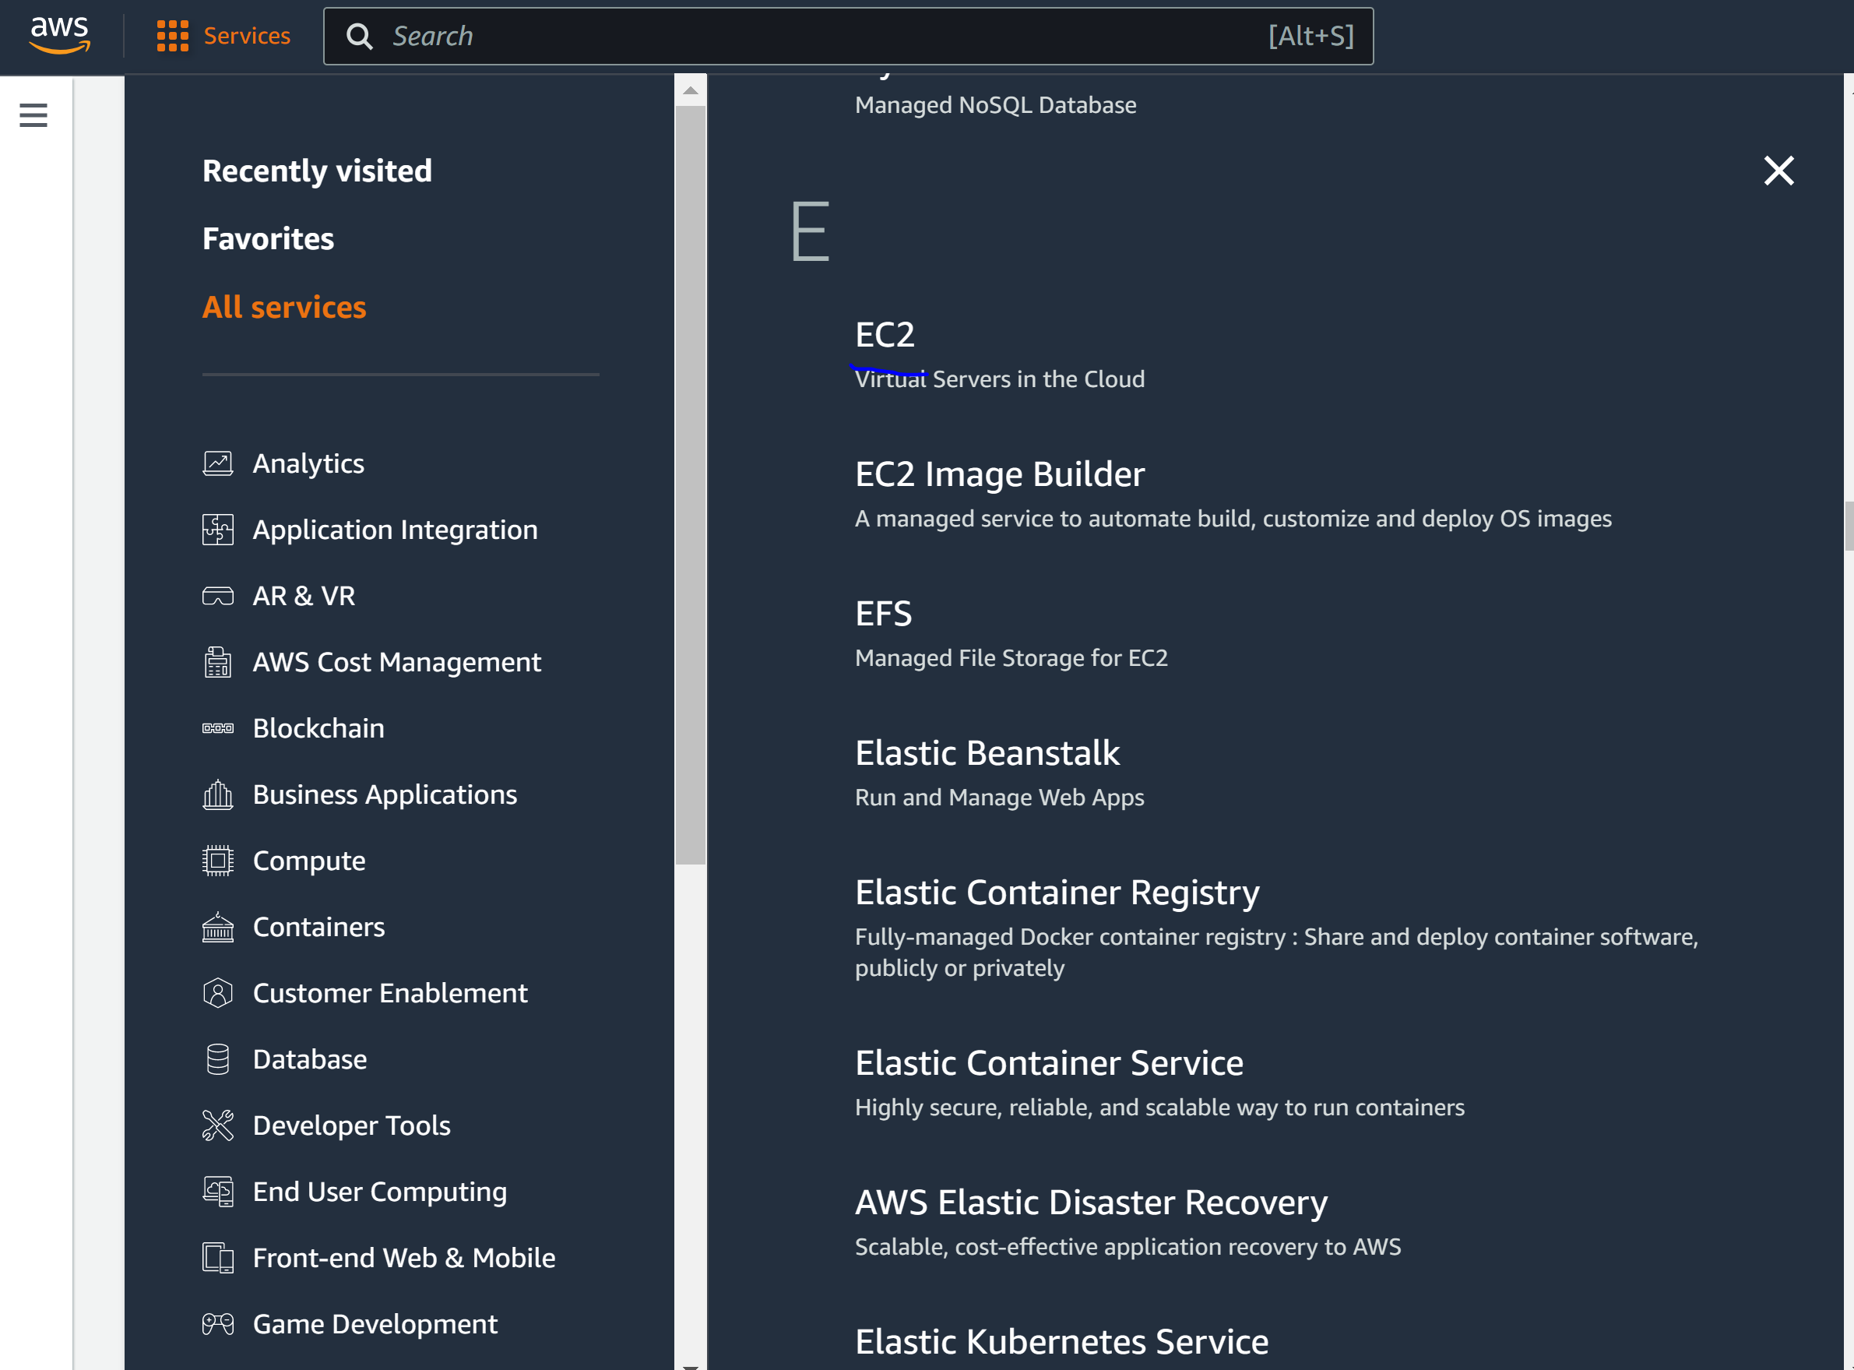

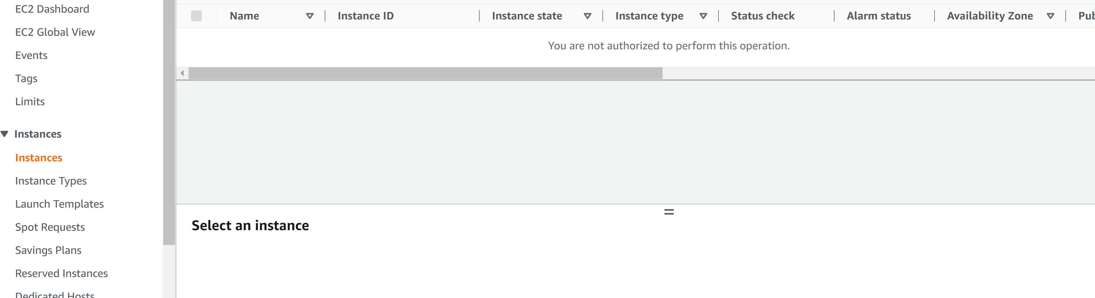

Step 11: log out of user-1 and log into user-2 with

* User: user-2
* Pass: Lab-Password2

Step 12: go to EC2 instances on user-2. You should have permission to view it.

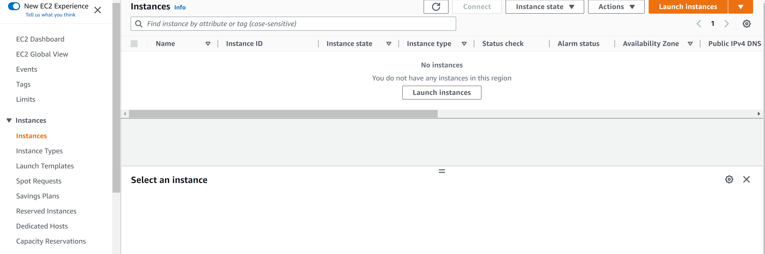

Step 13: go the region where the EC2 instances are. In this case, they are in N. Virginia

Step 14: Stop the instance

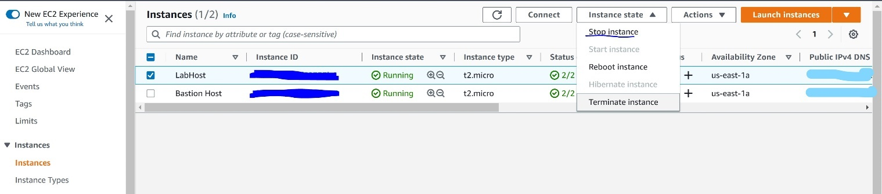

An error message should appear since user-2 only has read-only permissions.

Step 15: Sign out of user-2 and sign into user-3 with the following credentials

* User: user-3
* Pass: Lab-Password3

Step 16: go to EC2 instances and stop the LabHost instance. This should be successful.

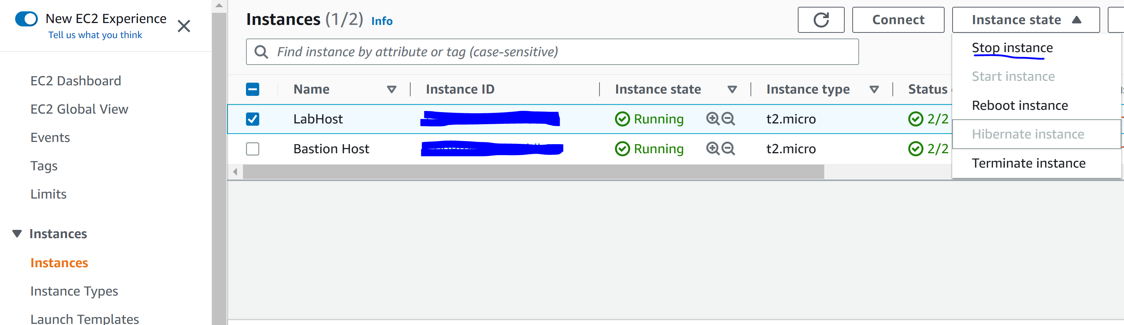

Step 17: end the lab.

Module 5: Network and Content Delivery

A computing network is made up of two or more machines that are connected to communicate. Networks are partitioned into subnets. Each machine has an IP address assigned to it. An IPv4 address is a 32 bit address. An IPv6 address is made up of 128 bits. Classless Inter-Domain Routing or CIDR is the first IP address of a network which is then followed by a “/” and a number.

The OSI model is a conceptual model used to explain data as it travels over a network. It consists of seven layers.

Amazon VPN enables provisioning of a logically isolated section of the AWS cloud where you can launch AWS resources in a virtual network. Subnets can be private or public where public ones have access to the internet and private ones do not. Once you choose IP addresses in this, you can’t change it. Smallest subnet size is /28 and largest is /16. Five IP addresses are reserved per subnet. E.g. /24

* .0 for network address
* .1 for internal communication
* .2 for DNS
* .3 for future use
* .255 for network broadcast

A public ipv4 address is manually assigned through an elastic IP address. It is automatically assigned through the auto-assign public IP address settings at the subnet level. An elastic IP address is associated with an AWS account. It can be allocated and remapped any time. Additional costs may apply.

Elastic network interfaces is a virtual network interface that can be attached or detached from an instance. When detached and reattached to another instance, it will redirect network traffic. The attributes on the interface follow when reattached.

An internet gateway is scalable, redundant, and highly available VPC component that allows communication between instances in your VPC and the internet. The internet gateway serves two purposes. One, provide a target for VPC routing tables with traffic for the internet and, two, perform address translation. AWS does do NAT.

VPC sharing enables customers to share subnets with other AWS accounts in the same organization. VPC peering allows a private connection to route traffic between two VPCs. By default, the VPC cannot communicate with own remote network. However, communication is possible with a site-to-site VPN. This is done by attaching a virtual private gateway to the VPC, creating a custom routing table, updating security group rules, and configure routing to pass through traffic to the connection.

AWS Direct Connect enables you to establish a dedicated private connection between your network and one of the direct connect locations. A private connection can increase bandwidth, throughput, and consistency. Direct connect used open stand 802.1q VLANs. A VPC endpoint is a virtual device that enables you to privately connect a VPC to supported AWS services. Traffic between AWS services and VPC are private.

AWS Transit Gateway is a transit gateway hub that is used to interconnect multiple VPCs. It is a hub and spoke topology.

VPC security groups act at the instance level and acts a virtual firewall that controls inbound and outbound traffic. Security groups have rules to manage instance traffic. Security groups are stateful. Outbound traffic is always allowed.

Network ACLs act at the subnet level. Controls traffic in and out of the subnet. Default ACL allows all inbound and outbound traffic. ACLs are stateless.

Amazon Route 53 DNS resolution. DNS resolution is the process of translating an internal name to the corresponding IP address. DNS stands for domain name system and functions like a phone book where IP address of corresponding machines.

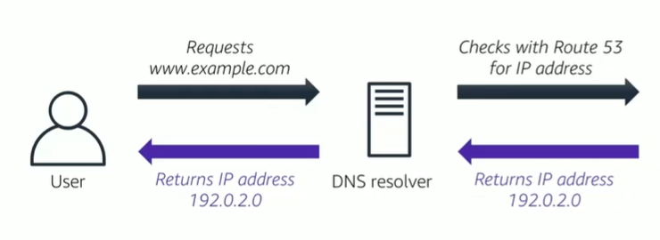

Amazone Route 53 allows you to register a domain name. supported routing includes:

* Simple routing: use in single-server environments
* Weighted routing: assign weights to resource record sets to specify the frequency
* Latency routing: help improve your global applications
* Geolocation routing: route traffic based on location of users
* Geo-proximity routing: route traffic based on locate of your resources
* Failover routing: fail over to a backup site if your primary site becomes unreachable
* Multivalued answer routing: respond to DNS queries with up to eight healthy records selected at random

Amazon CloudFront. A fast content delivery service that security delivers data to customers at high transfer speeds. CloudFront delivers files to users over a global network of edge locations. Pay-as-you-go pricing.

**Lab 2** **Build a VPC and launch a Web Server**

Step 1: Click “start lab” and click “aws”

Step 2: verify that the region is N. Virginia



Step 3: open “services” and got to “VPC”

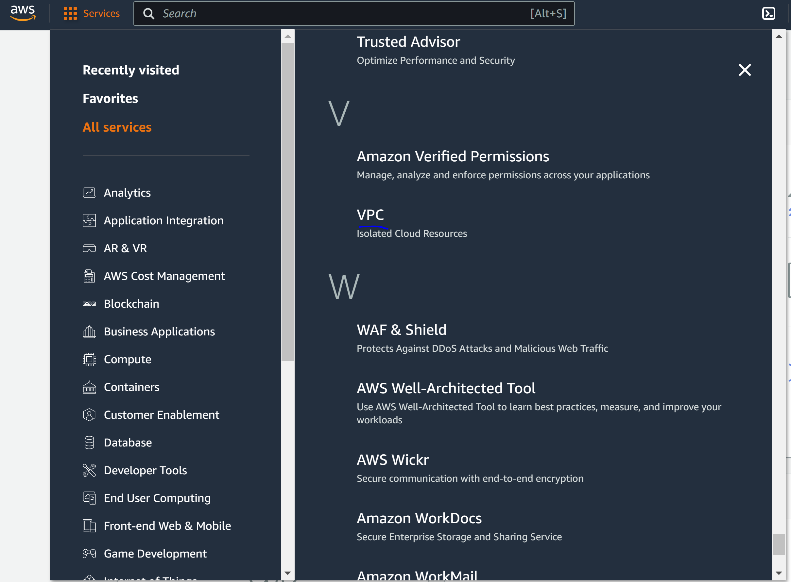

Step 4: Create VPC

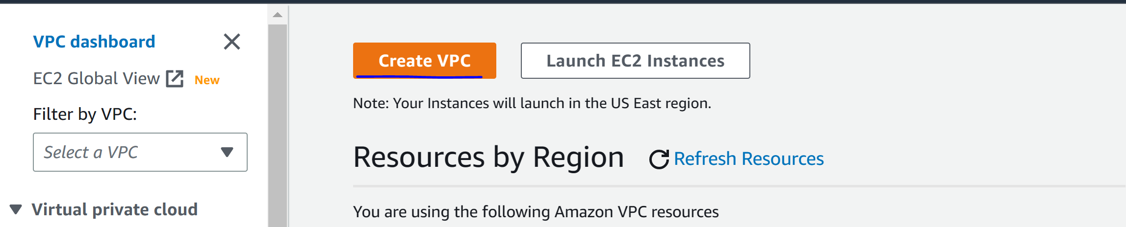

Step 4: configure the following

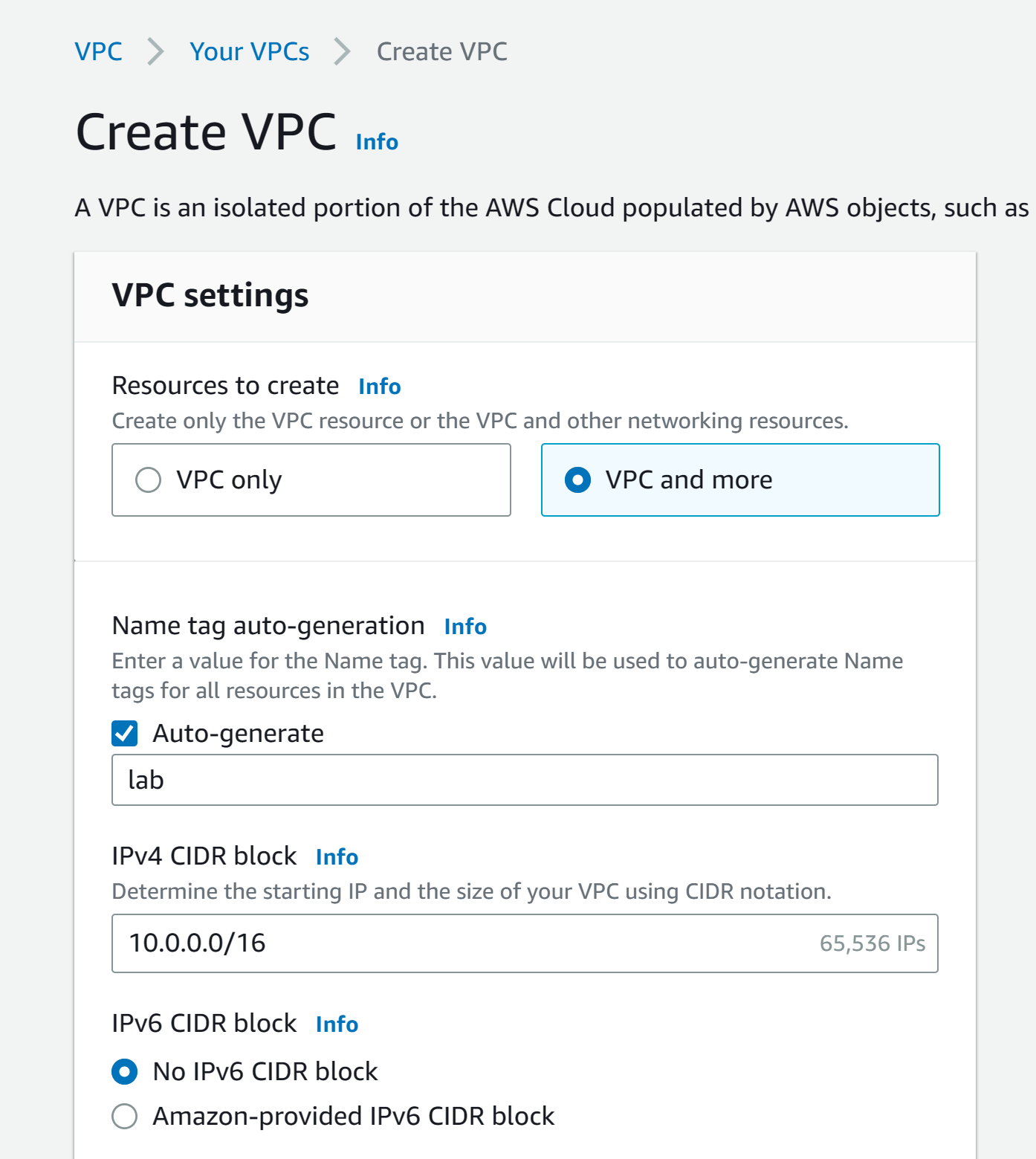

Step 5: configure the following

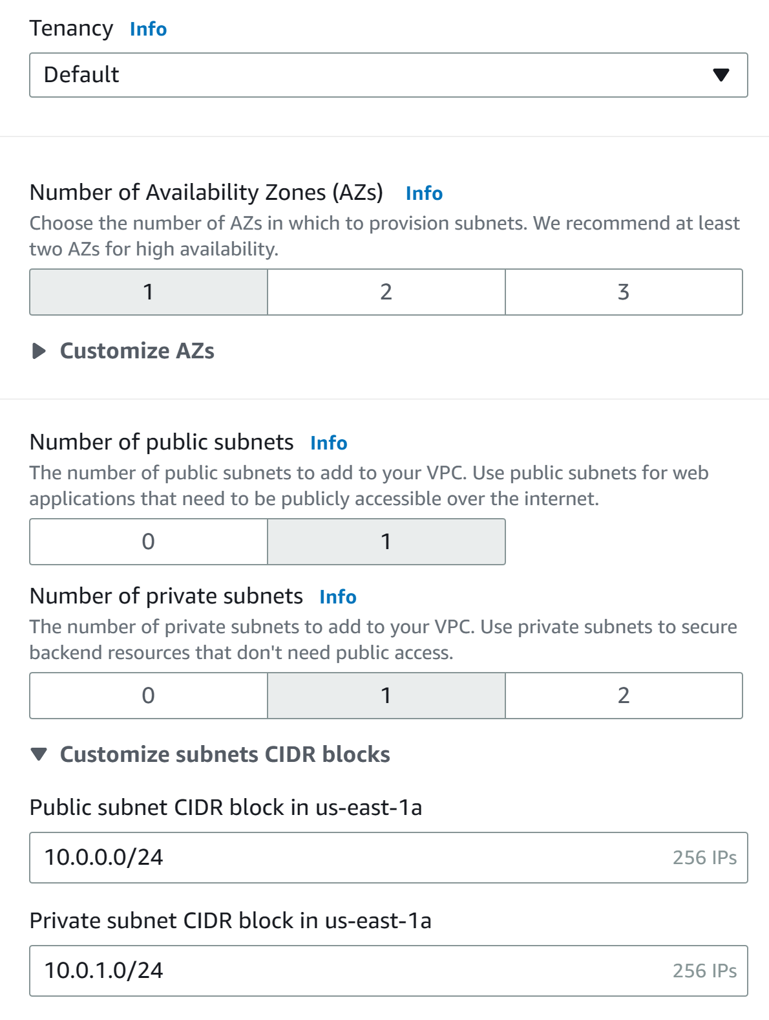

Step 6: configure the following. Click “create VPC” and wait for all resources to activate.

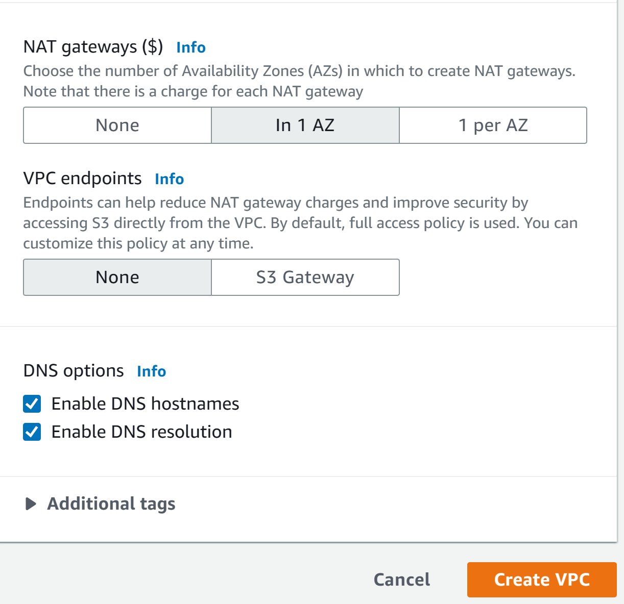

Step 7: click “view VPC”

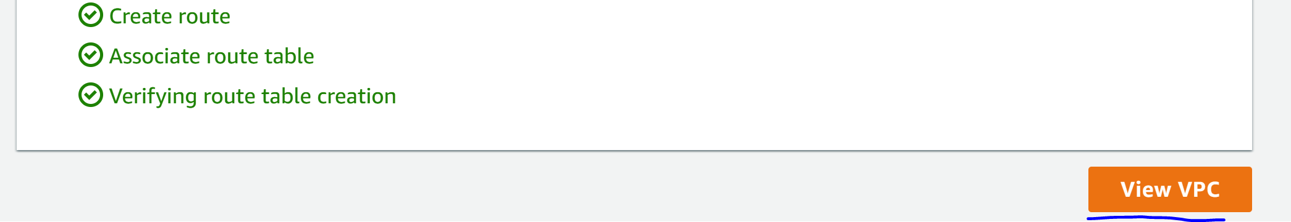

Step 8: click “subnets”

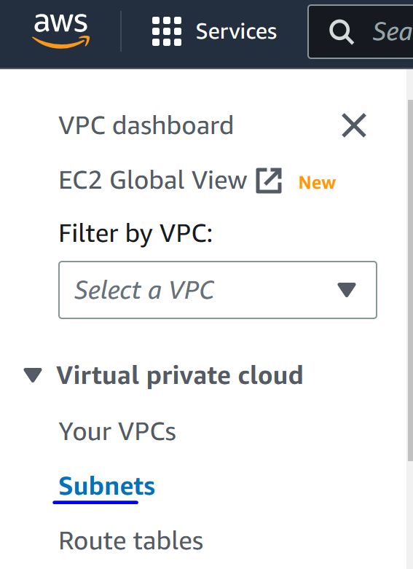

Step 9: click “create subnet” and configure the following. Create subnet.

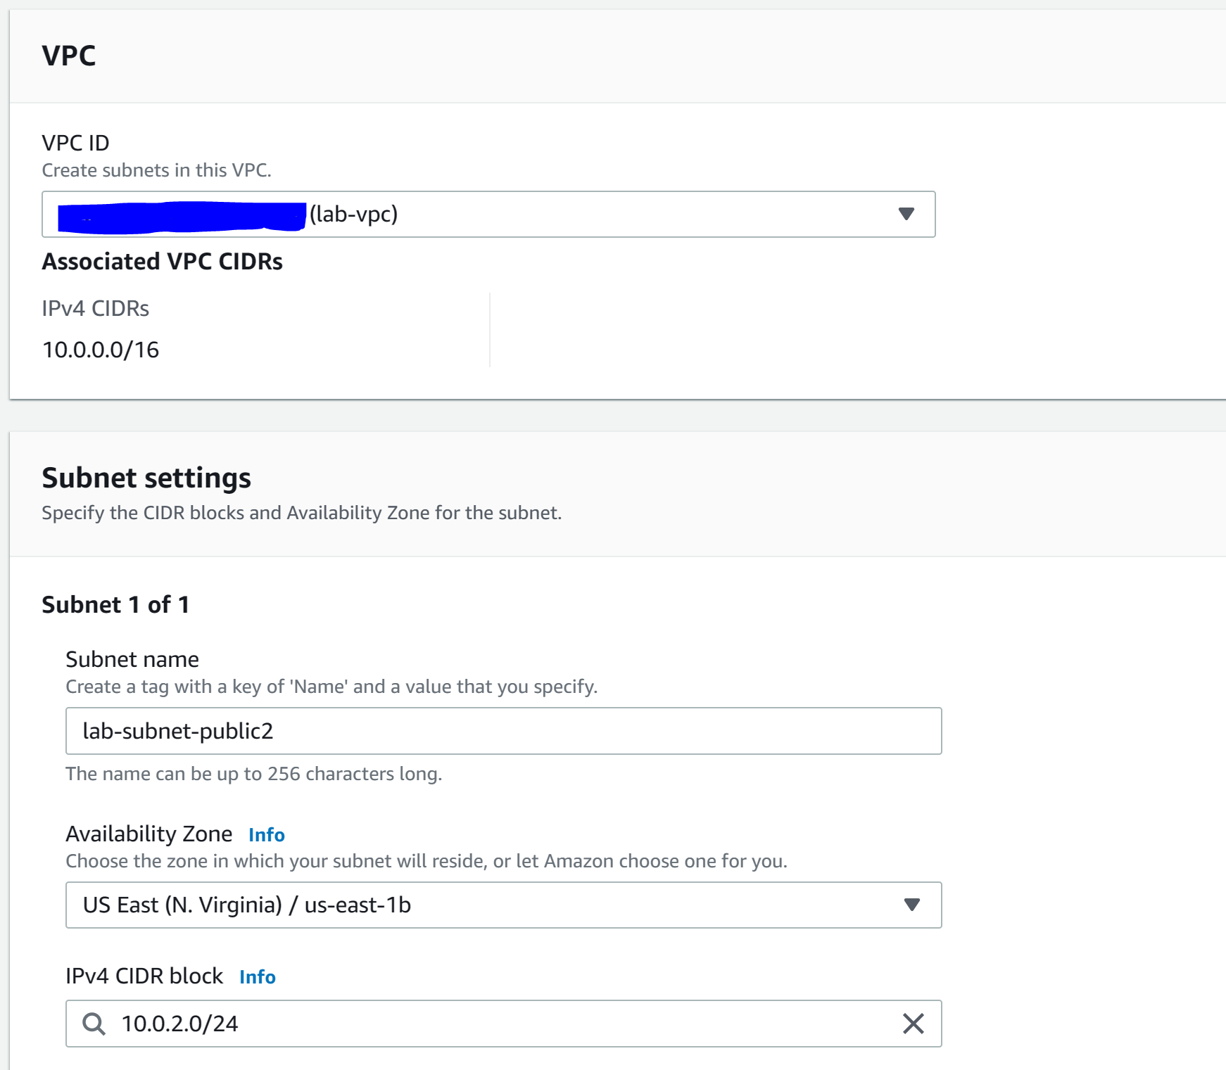

Step 10: click “create subnet” and configure the following. Create subnet.

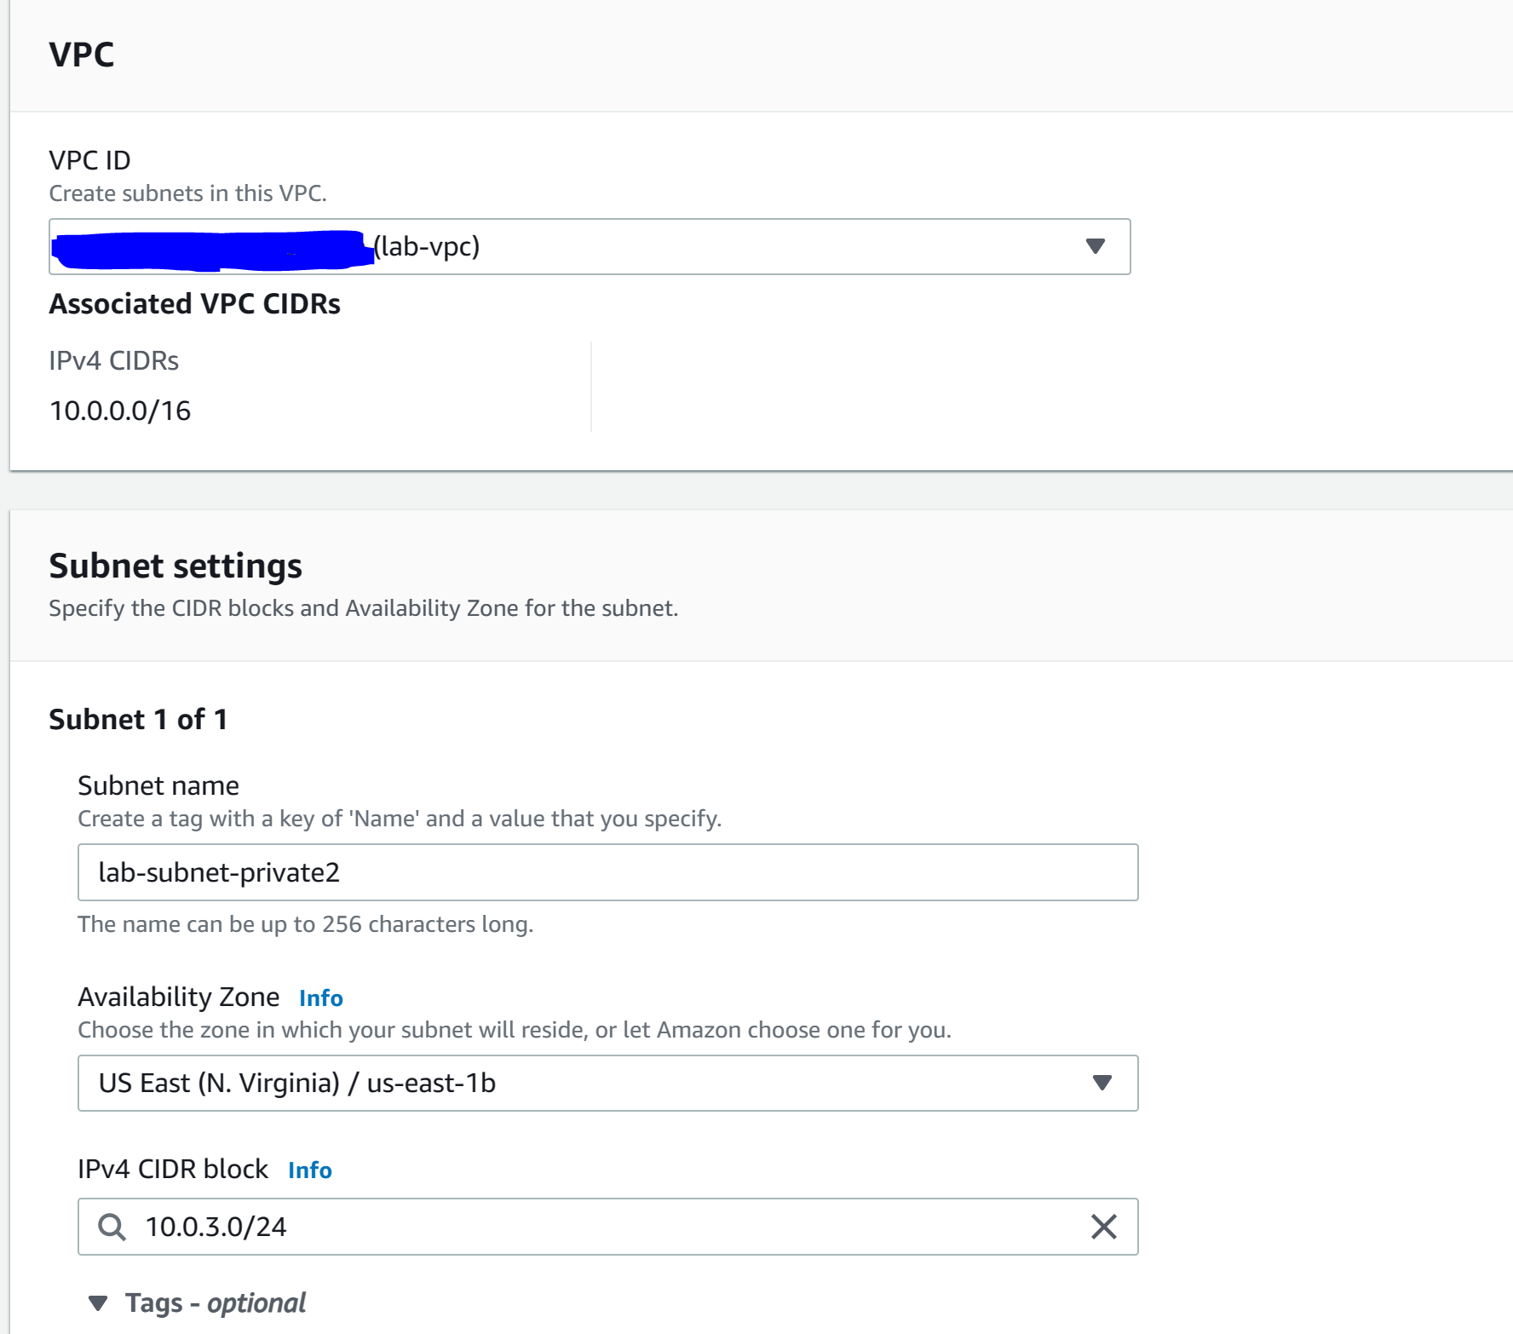

Step 11: Go to “routing tables”, click “lab-rtb-private…” and got to “subnet associations”. Click “edit subnet associations.”

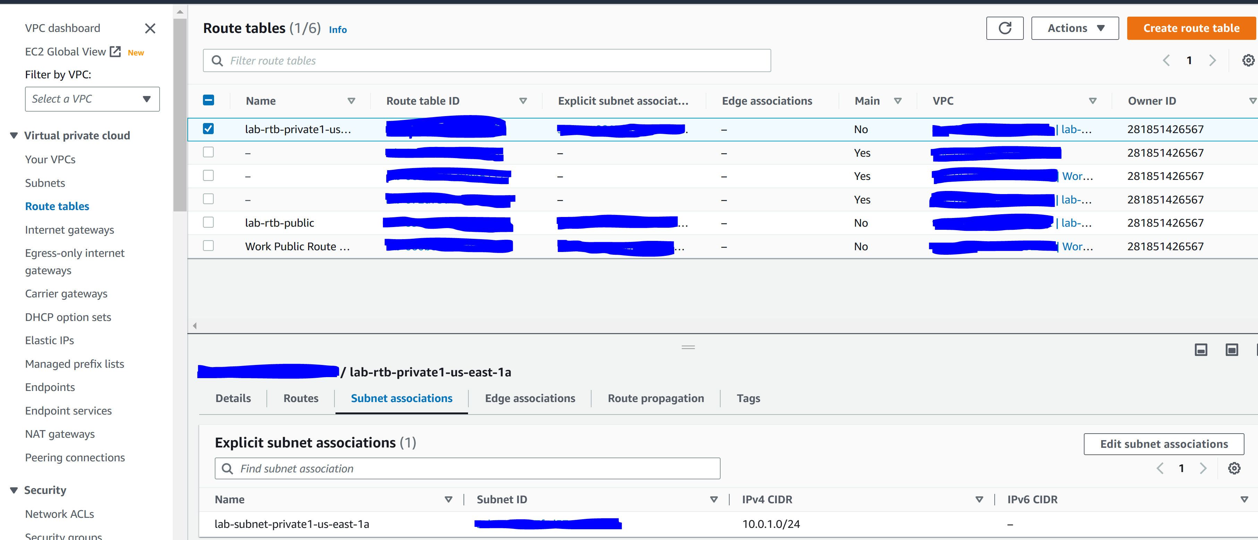

Step 12: select “lab-subnet-private2.” Click “save associations”

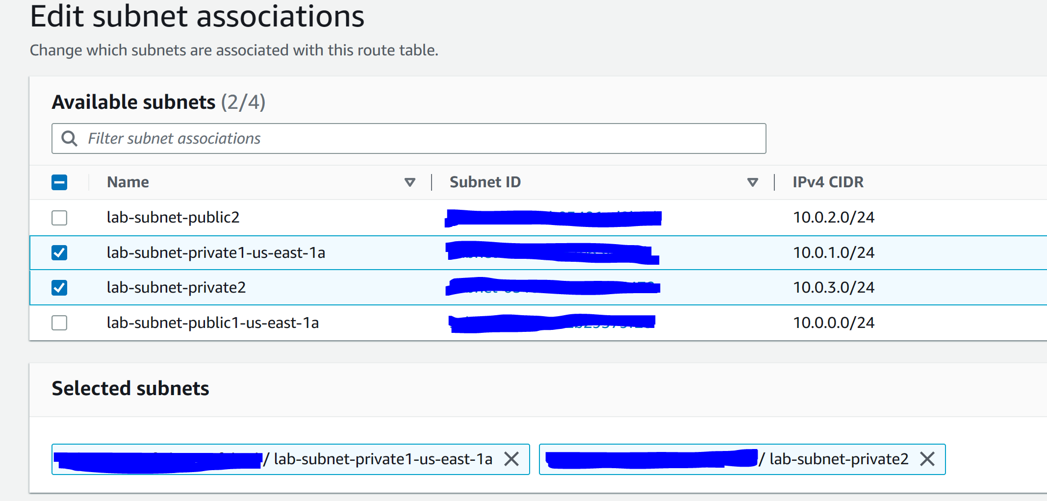

Step 13: Go to “routing tables”, click “lab-rtb-public” and got to “subnet associations”. Click “edit subnet associations.”

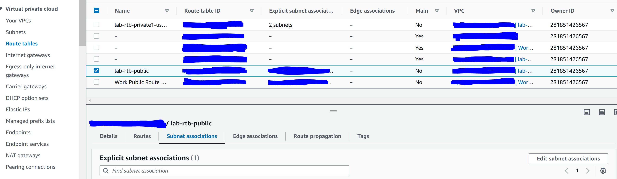

Step 14: select “lab-subnet-public2.” Click “save associations”

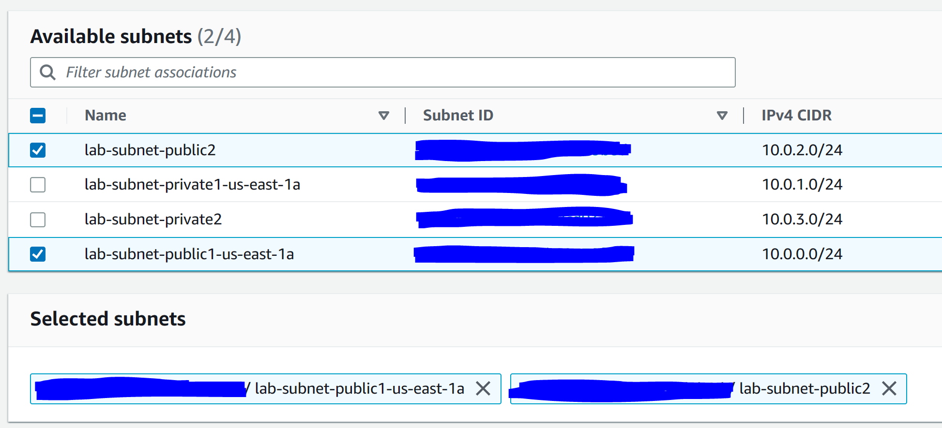

Step 15: go to “security groups” and click “create security group”

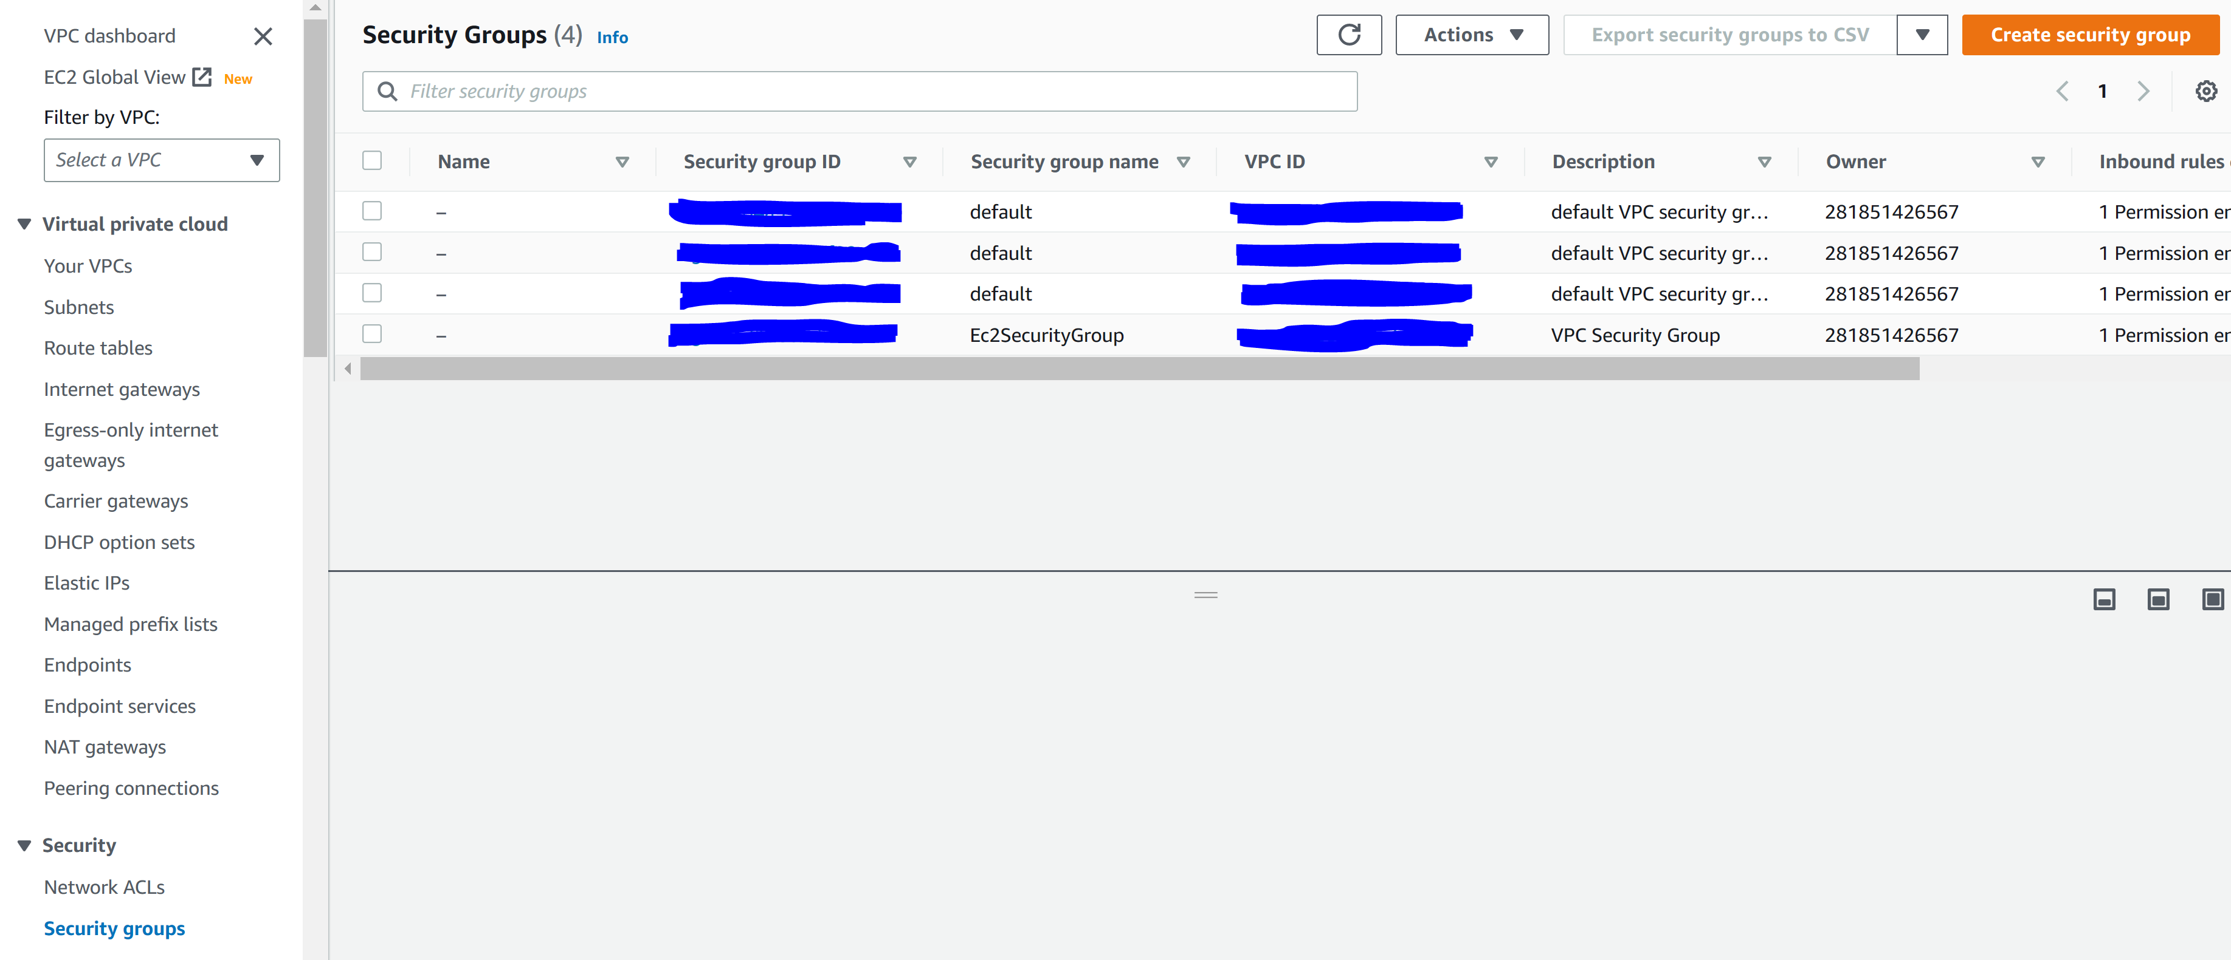

Step 16: configure the following. Create security group.

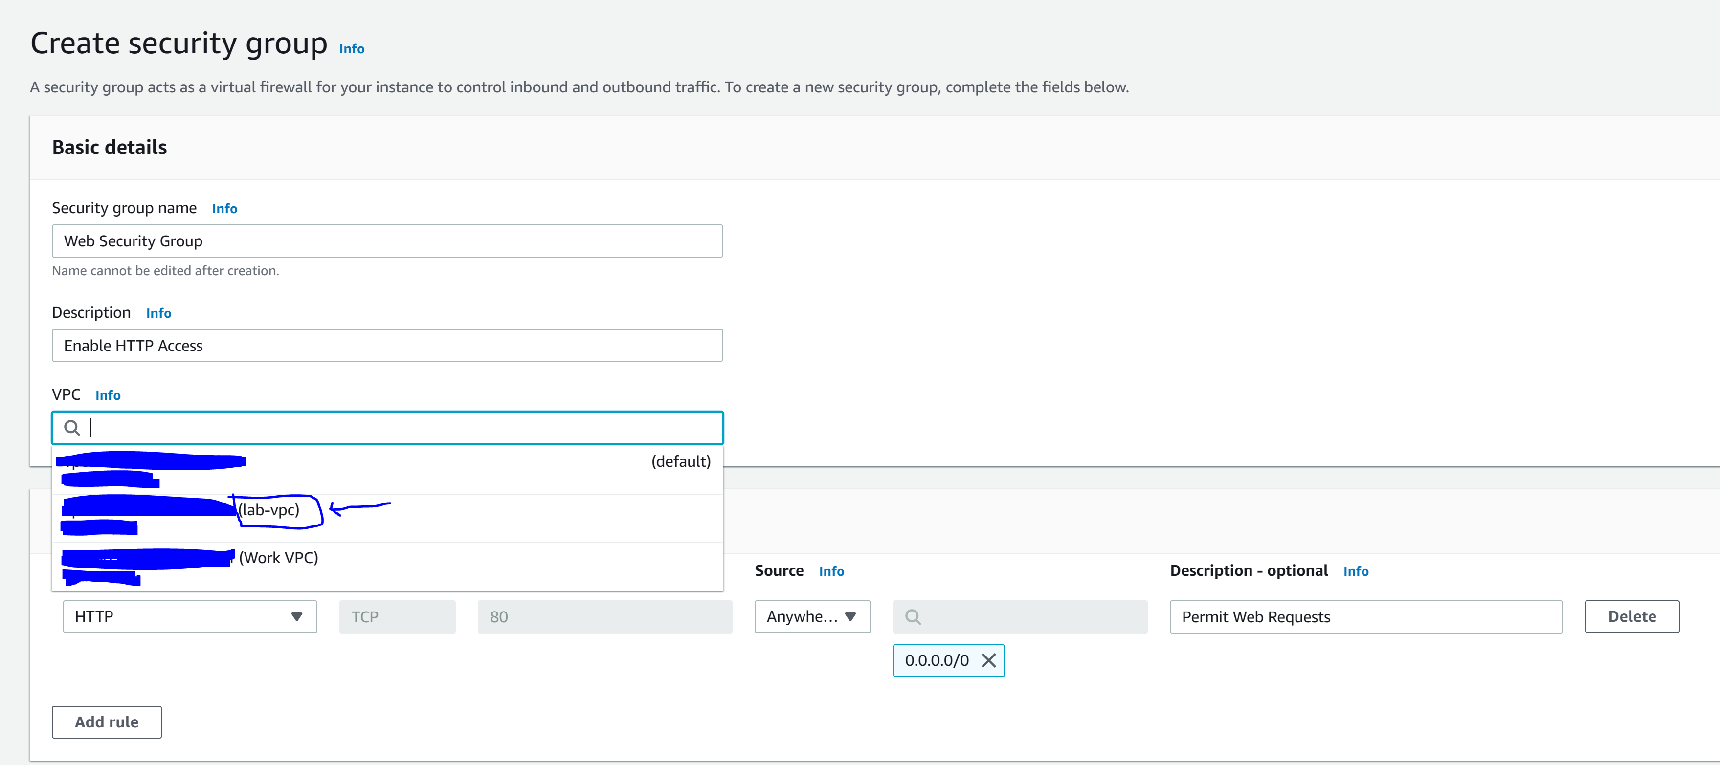

Step 17: got to AWS EC2

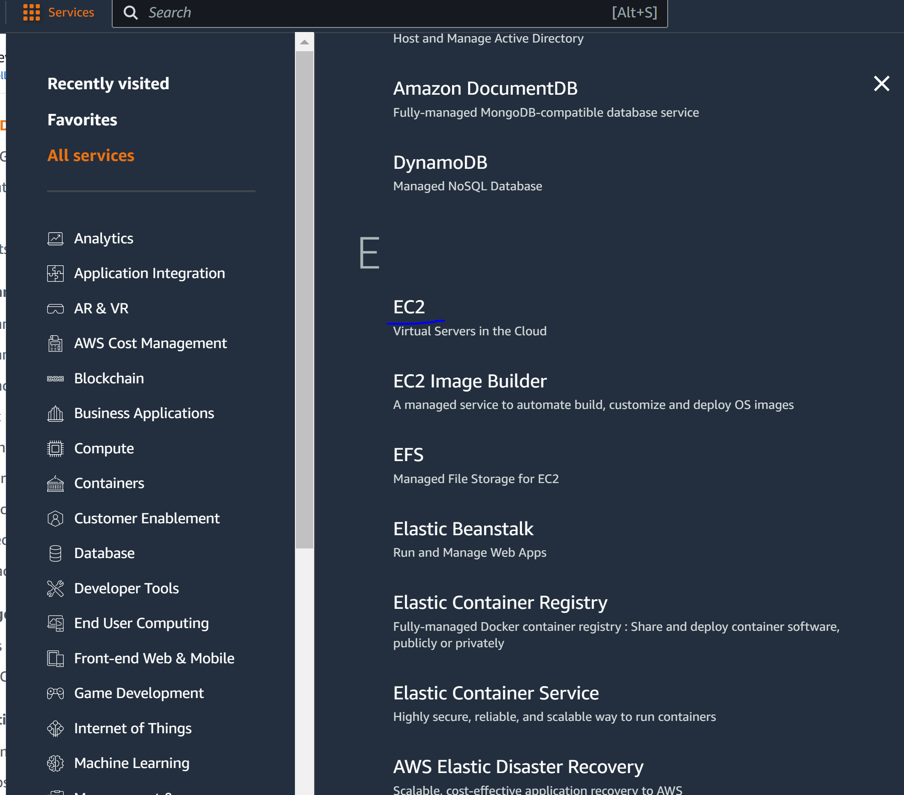

Step 18: Launch an instance

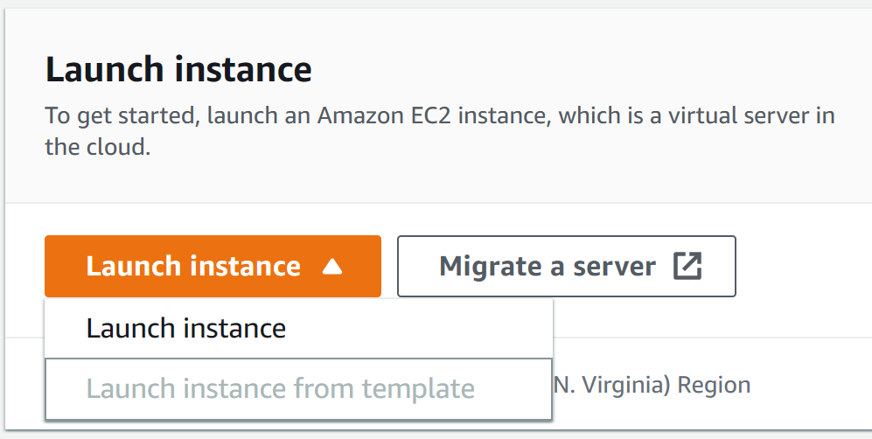

Step 19: configure the following

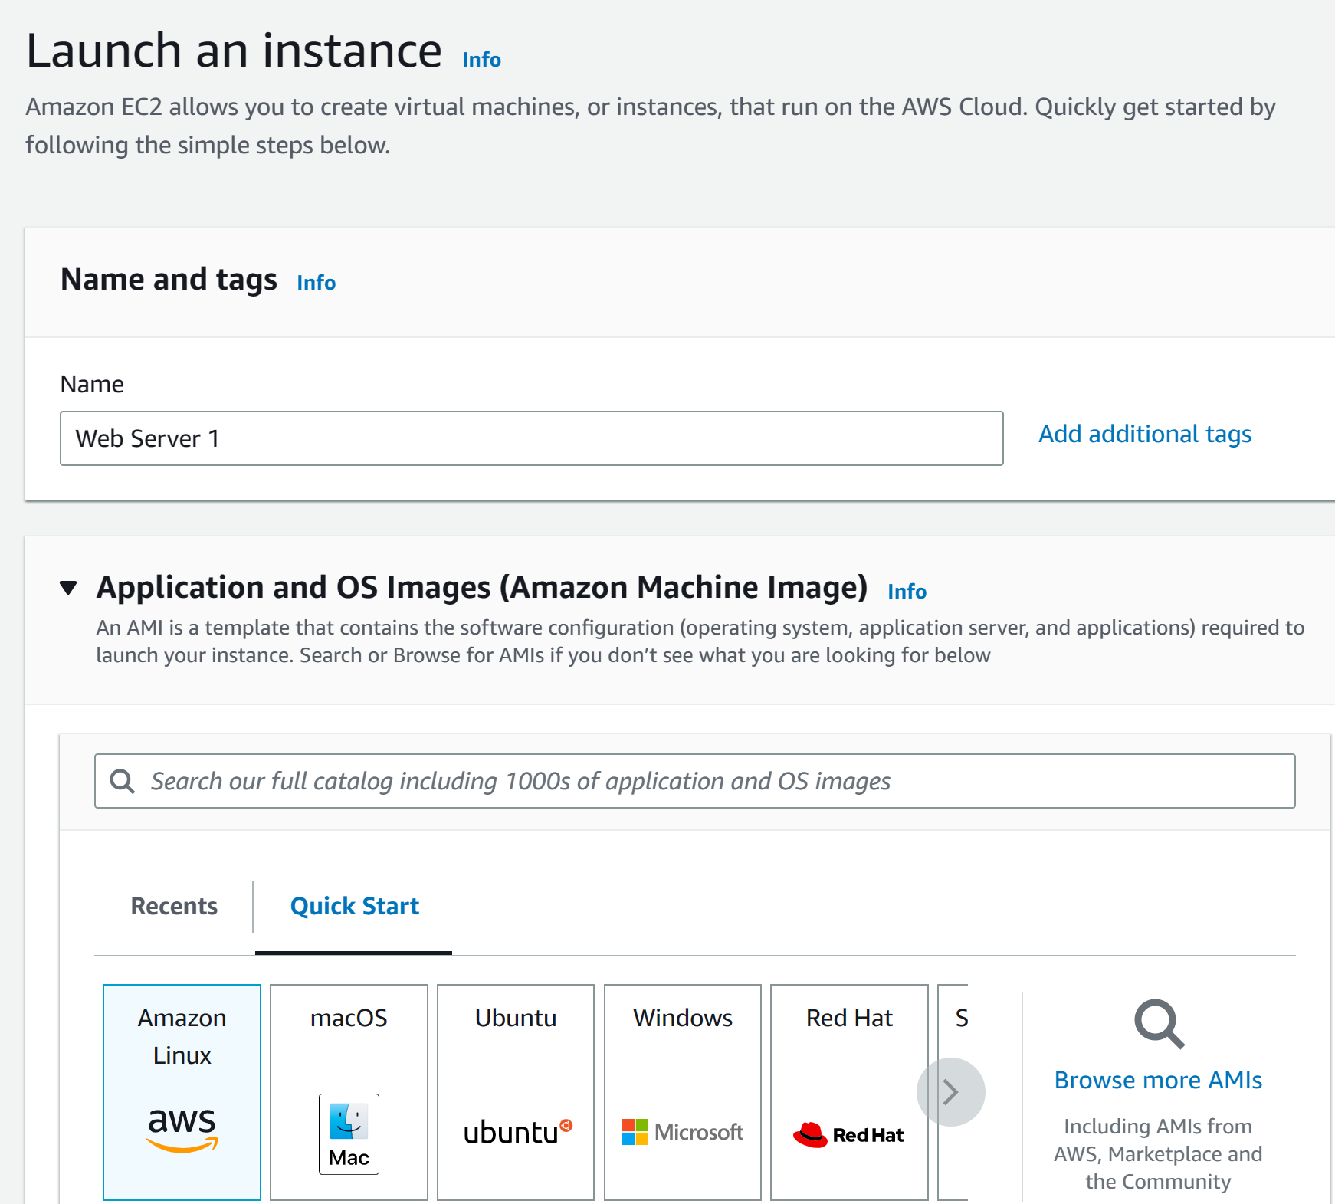

Step 20: configure the following

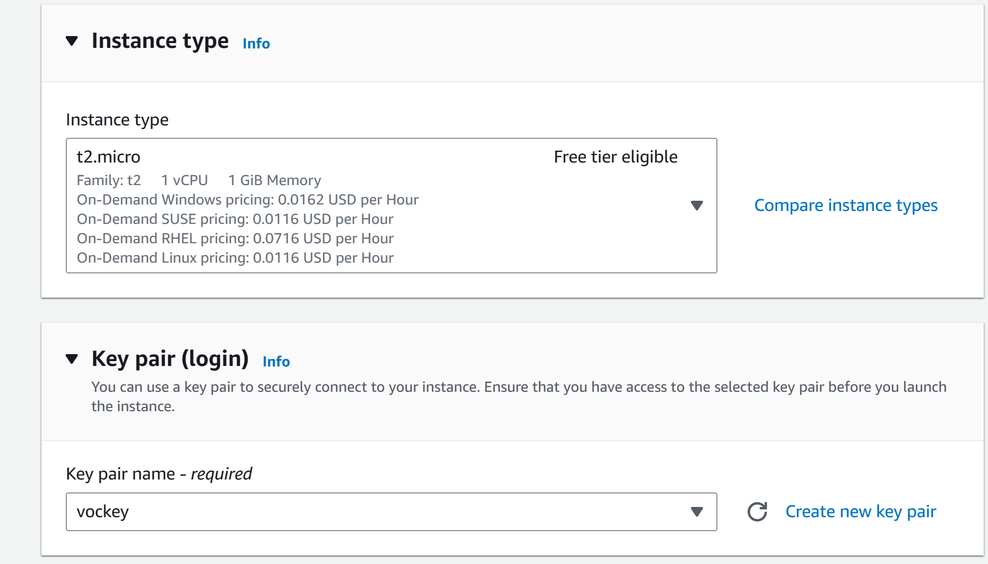

Step 21: configure the following

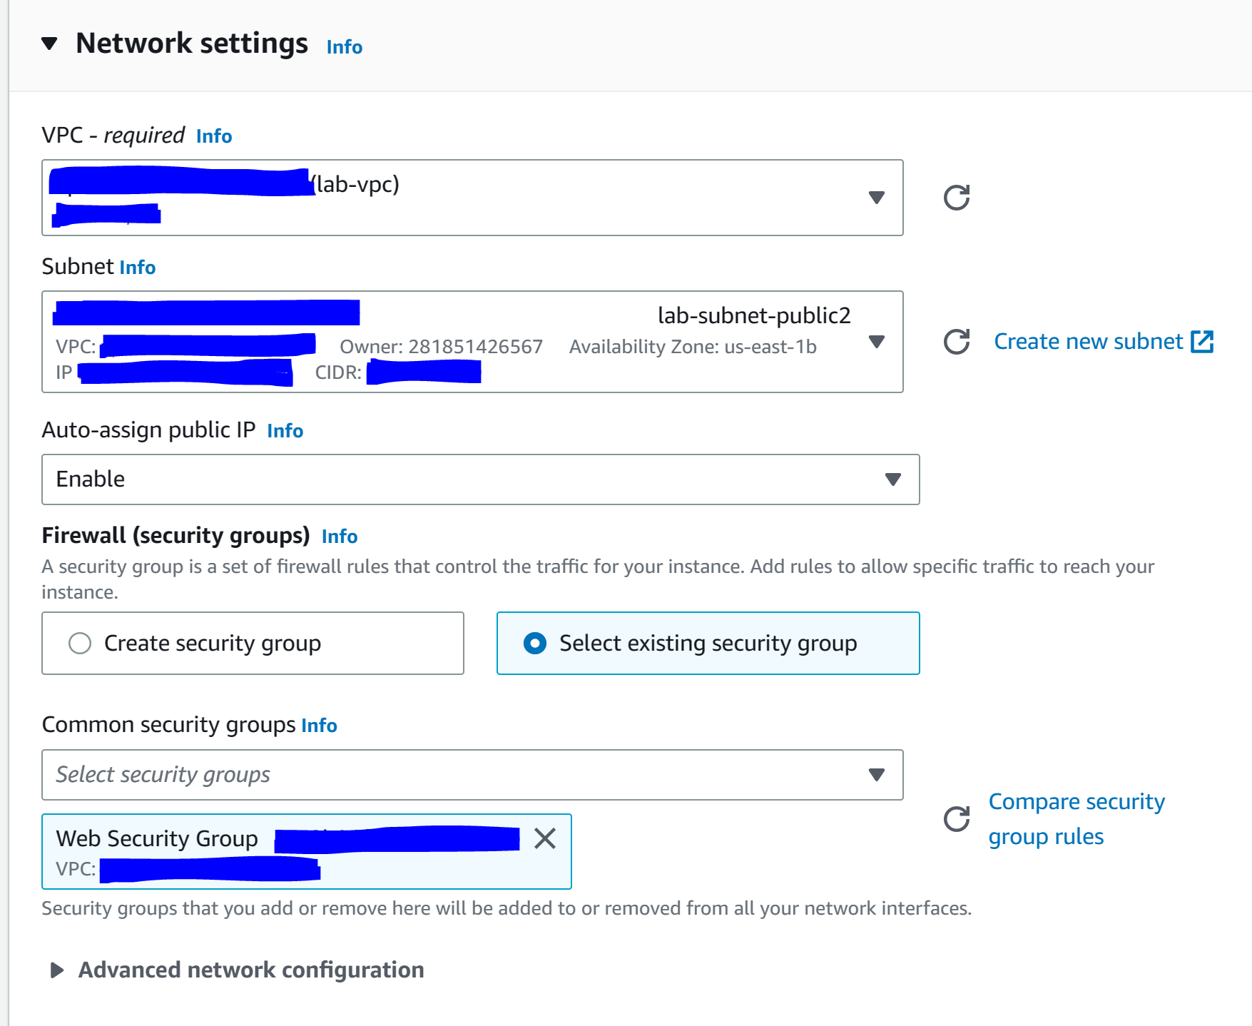

Step 21: configure the following under “advanced details”

Here is the text:

#!/bin/bash

# Install Apache Web Server and PHP

yum install -y httpd mysql php

# Download Lab files

wget https://aws-tc-largeobjects.s3.us-west-2.amazonaws.com/CUR-TF-100-ACCLFO-2-9026/2-lab2-vpc/s3/lab-app.zip

unzip lab-app.zip -d /var/www/html/

# Turn on web server

chkconfig httpd on

service httpd start

This script will run with root user permissions on the guest OS of the instance. It will run automatically when the instance launches for the first time. The script installs a web server, a database, and PHP libraries, and then it downloads and installs a PHP web application on the web server.

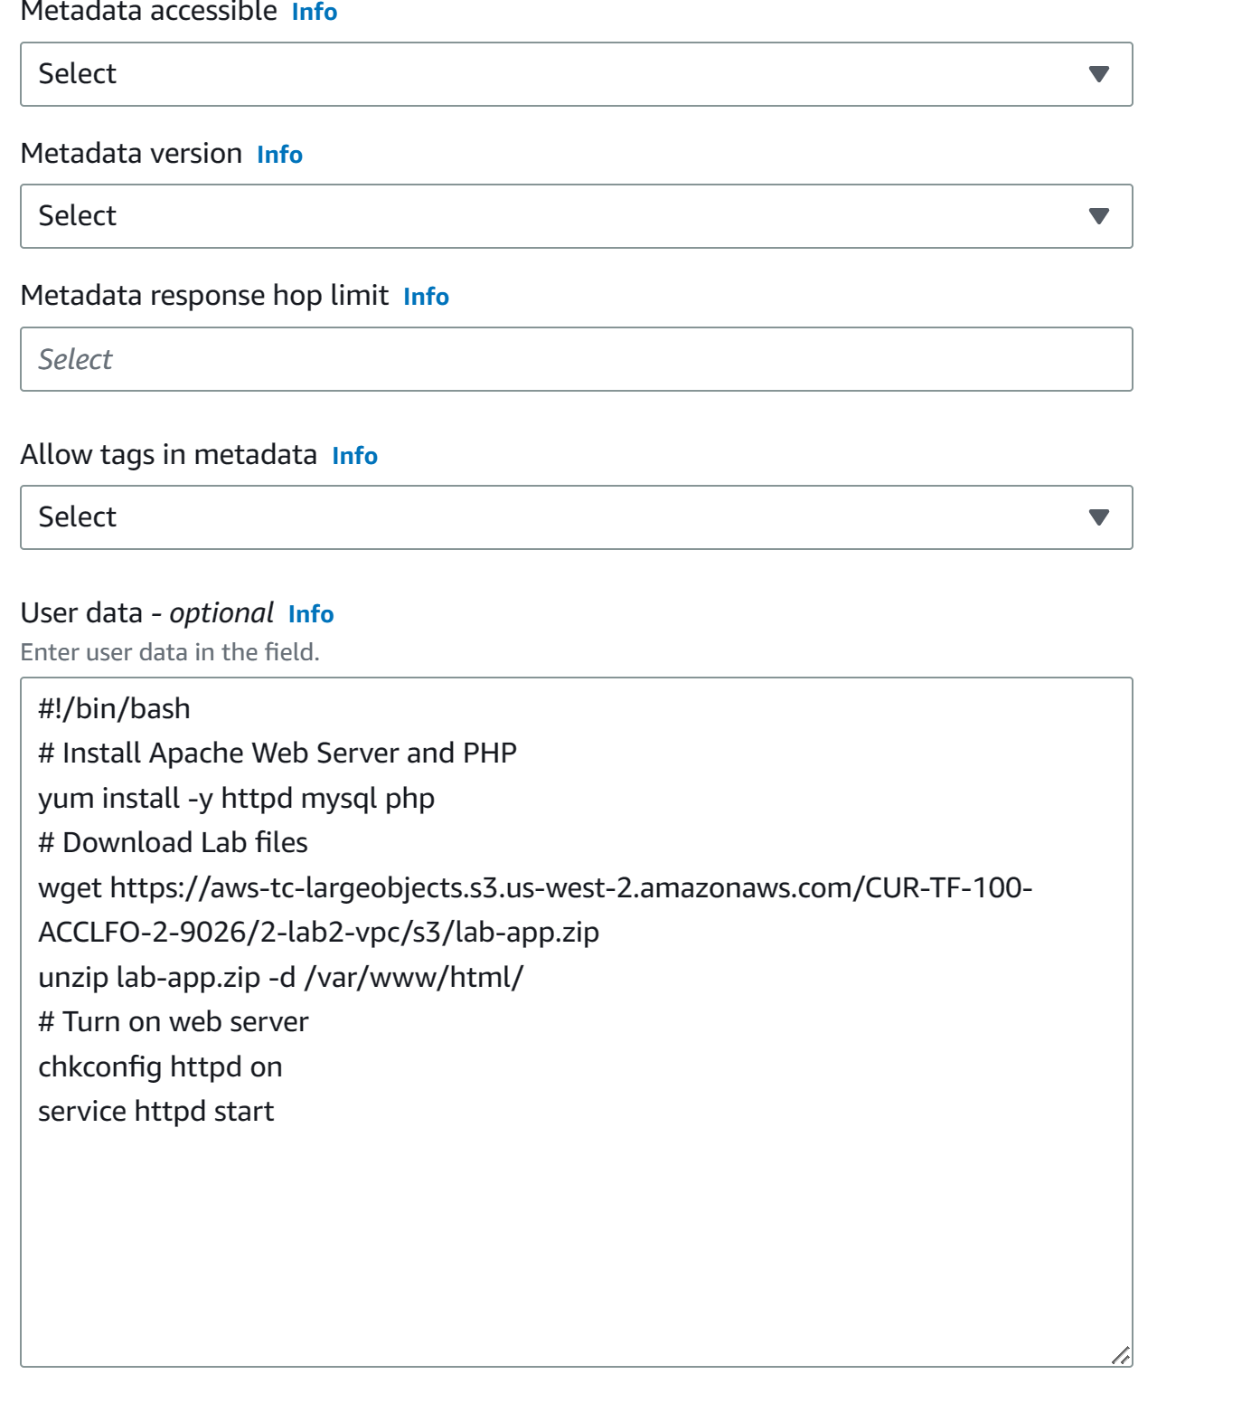

Step 22: Click “launch instance” and then “view instances”.

Step 23: wait for “Web Server 1” to finish 2/2 status checks

Step 24: go to “instances”, “web server 1” and copy the Public IPv4 DNS into a new tab.

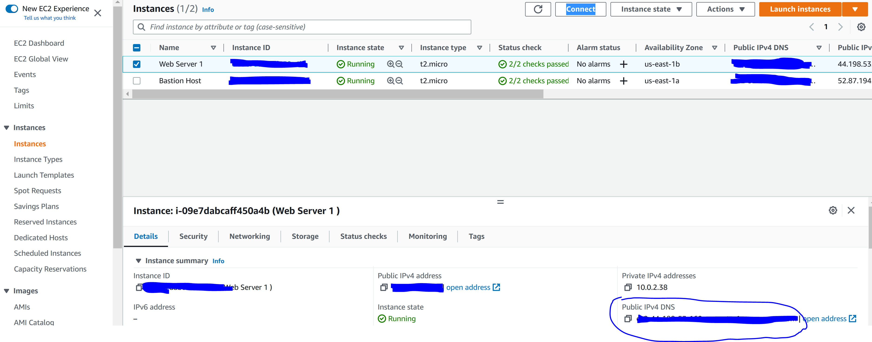

Step 25: click “end lab”

Module 6: Compute Services Overview

Amazon compute services includes Amazon EC2, Amazon Elastic Container Registry, Amazon Elastic Container service, Amazon Elastic Beanstalk, AWS Lambda, Amazon Elastic Kubernetes Services, Amazon Fargate, and more.

AWS computing services belong to four main categories:

* IaaS compute that provides virtual machines (Amazon EC2)
* Serverless computing (AWS Lambda)
* Container-based computing (Amazon ECS, Amazon EKS, AWS Fargate, Amazon ECR)
* PaaS for web applications (Amazon Elastic Beanstalk)

The optimal compute service or services that is used is based on the context of the situation. For example, things to consider include: what is the application design, what are your usage patterns, which configuration settings will you want to manage?

Amazon Elastic Compute Cloud (Amazon EC2) provides virtual machines that can host same stuff as on-premises hardware. Users have full control over the operating systems whether it be windows, Linux, Red Hat, SUSE, and Ubuntu. Instances are launched from Amazon Machine Images (AMI). Multiple AMIs can be launched for different purposes. There are four categories of AMIs:

* Quick Start: Linux and Windows AMIs that are provided by AWS
* My AMIs: any AMIs that you created
* AWS Marketplace: pre-configured templates from third parties
* Community AMIs: AMIs shared by other users; use at your own risk

Creating a new AMI starts with quick start or with another existing AMI. Connect to an instance. Make modifications. Capture the modified instance as a new AMI.

When you create a new AMI, the AMI can be used to launch new instances in the same AWS region.

After creating an AMI, EC2 will need to select an instance. The instance type chosen determines RAM, CPU, Storage, and network performance. Instance types that can be chosen from can be optimized for a specific purpose such as general purpose (a1, m4, m5, t2, t3), compute optimized (high performance. c4, c5 ), memory optimized, (in-memory databases. r4, r5, x1, z1), storage optimized (distributed file systems. d2, h1, i3), and accelerated computing (machine learning. f1, g3, g4, p2, p3).

Instance names have meaning. For example, t3.large. T is the family name, 3 is the generation number, and Large is the size.

The EC2 instance can be launched inside of a VPC. If no VPC is selected, it is placed in the default VPC. A public IP address is assigned by default.

It is common to launch EC2 instances to run an application that must make calls to different AWS services. This can be done by attaching an IAM role to the EC2 instance. Never store AWS credentials on an EC2 instance.

When creating an instance, you have an option of passing user data to the instance. User can help automate configurations. User data scrips will run during the final phase of the boot process. By default, user data will only run the first time that the instance starts up.

Amazon EC2 storage options include Amazon Elastic Block Store durable storage. Amazon EC2 Instance Store. Other storage systems include Amazon Elastic File System and Amazon Simple Storage Service however these storage units will be lost on reboot.

A tag is a label that you can assign to an AWS resource. A tag consists of a key and an optional value. Tagging is how you can attach metadata to an EC2 instance.

A security group is a set of firewall rules that control traffic to the instance. It exists outside of the instance’s guest OS. Use a security group to create rules that specify the source and which ports that network communications can use. Specify port and protocol such as TCP 22 SSH.

A key pair consists of a public key that AWS stores and a private key that you store. Keys enable secure connections to the instance. For Windows AMIs, use the private key to obtain the admin password that you need to log into the instance. For Linux AMIs, use the private key to use SSH to securely connect to your instance.

AWS instances can also be launched with the AWS CLI. An example could be:

aws ec2 run-instances \

--image-id ami-1a2b3c4d \

--count 1 \

--instance-type c3.large \

--key-name MyKeyPair \

-- security-groups MySecuirtyGroup \

--regrion us-east-1

Rebooting an instance will not change any IP addresses or DNS hostname. When an instance is stopped and then started again the public ipv6 address and external DNS hostname will change.

**Lab 3 Introduction to Amazon EC2**

Step 1: Start the lab

Step 2: Click AWS

Step 3: Go to Services, Compute, and EC2

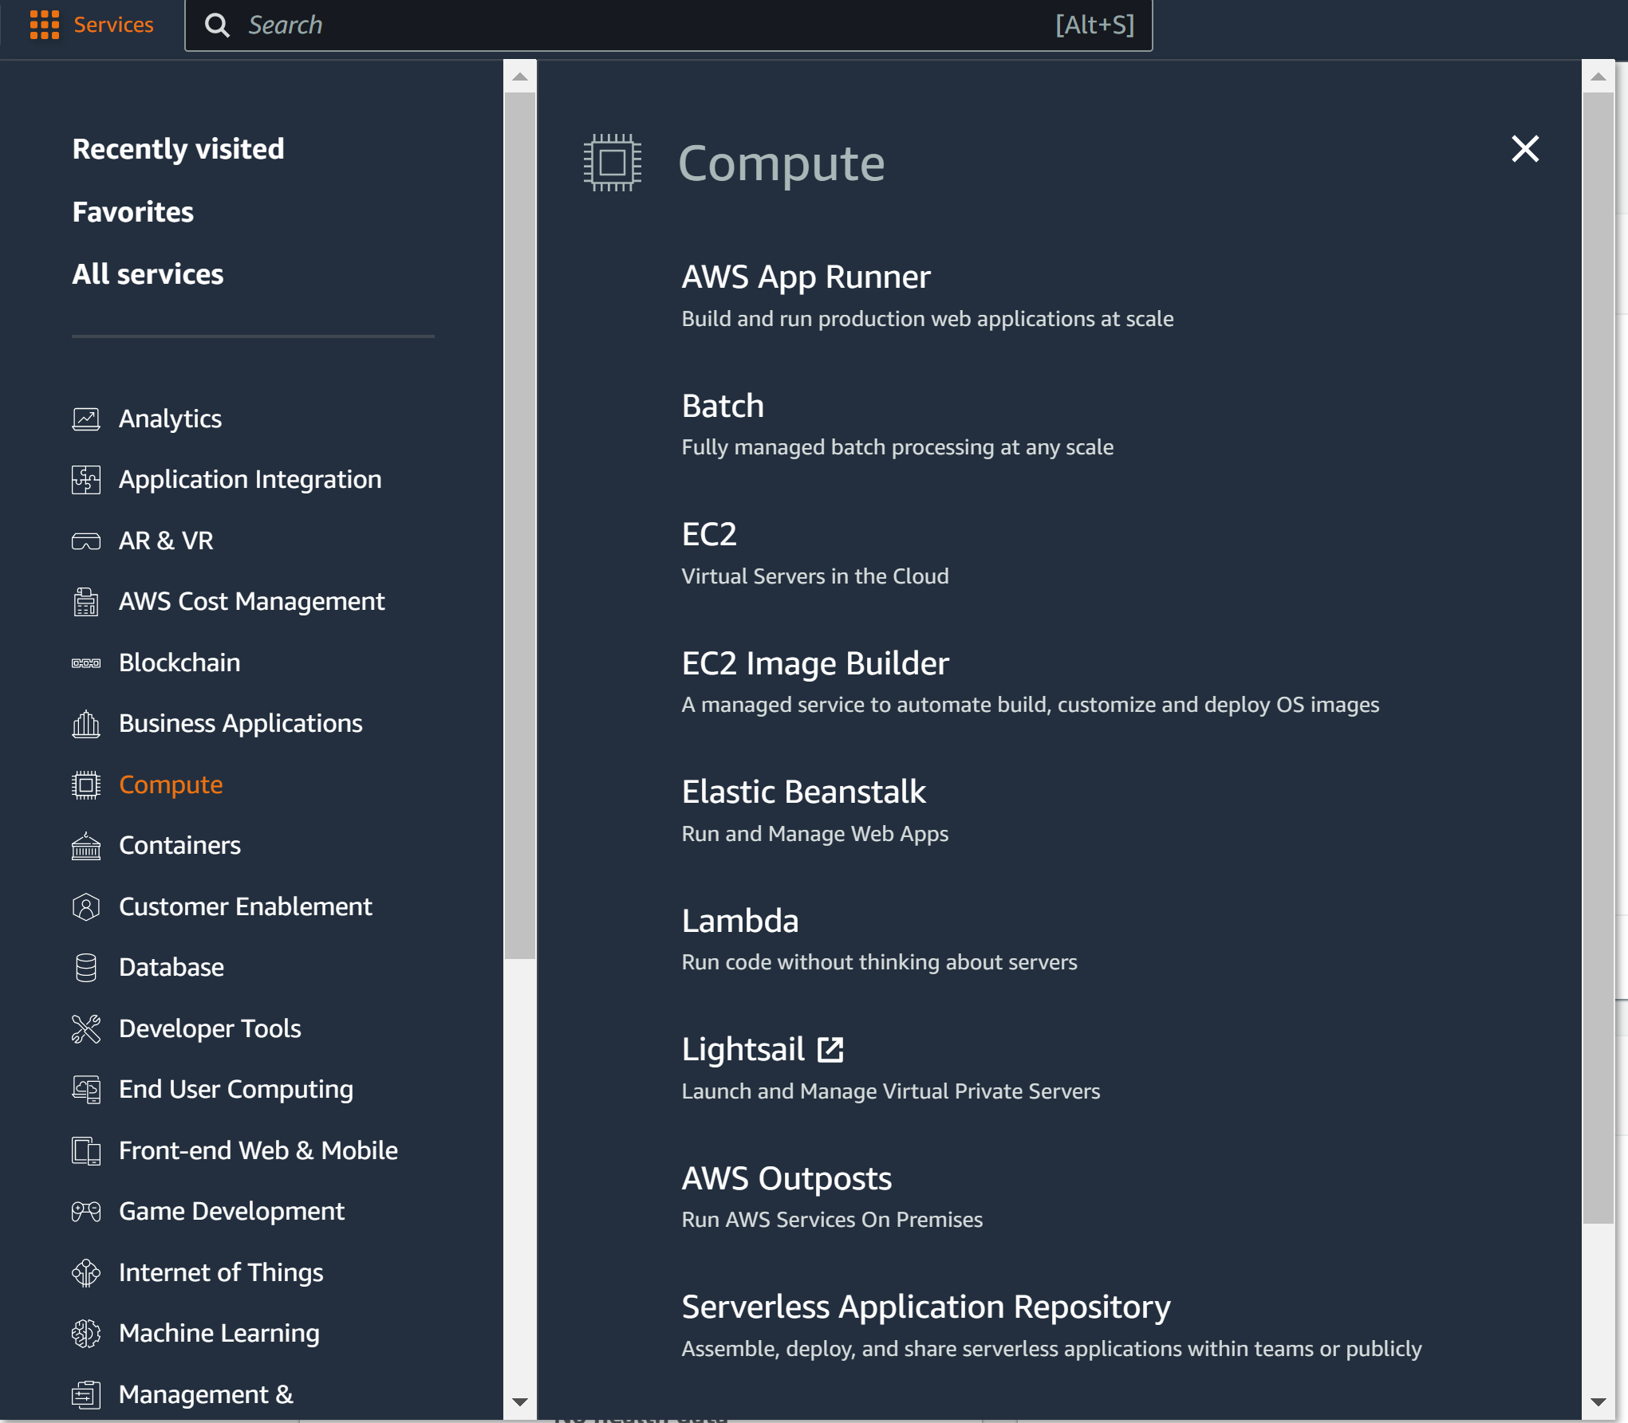\

Step 4: Click Launch Instance

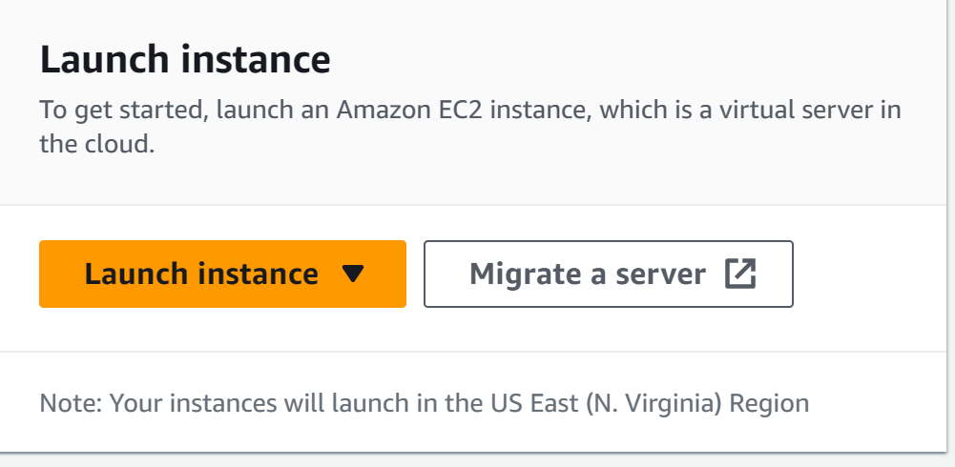

Step 5: configure the following:

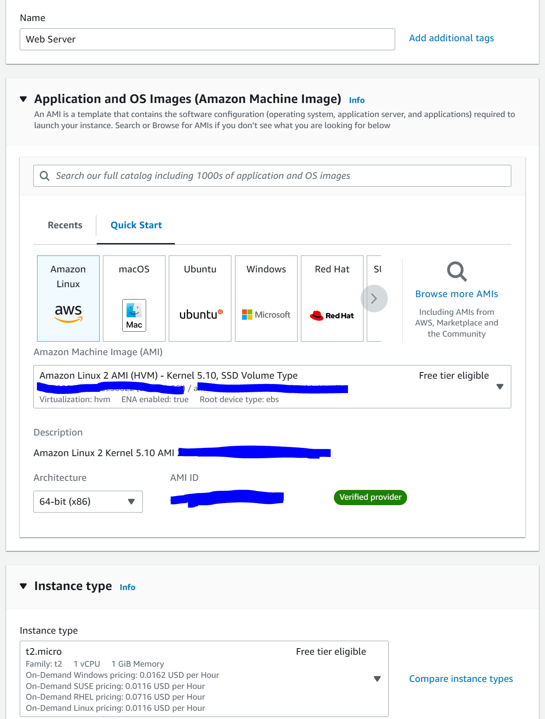

Step 6: configure the following

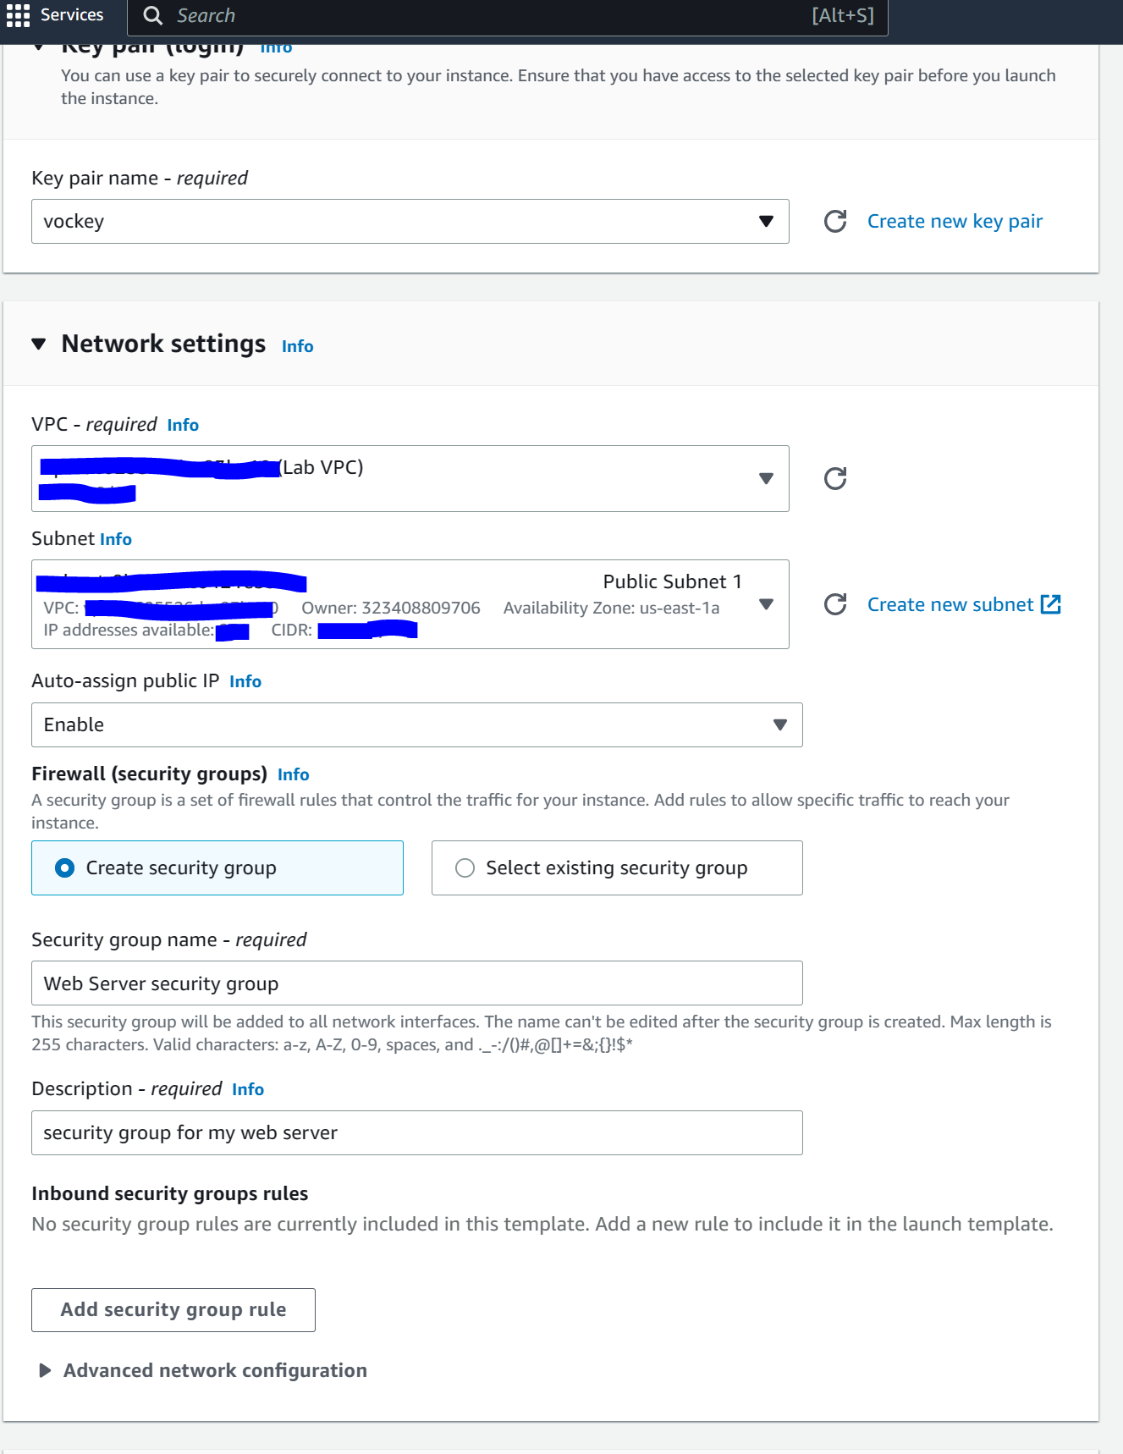

Step 7: open advanced details and configure the following

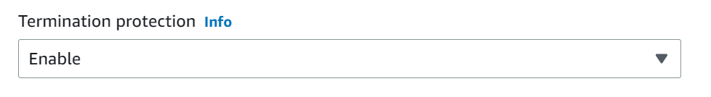

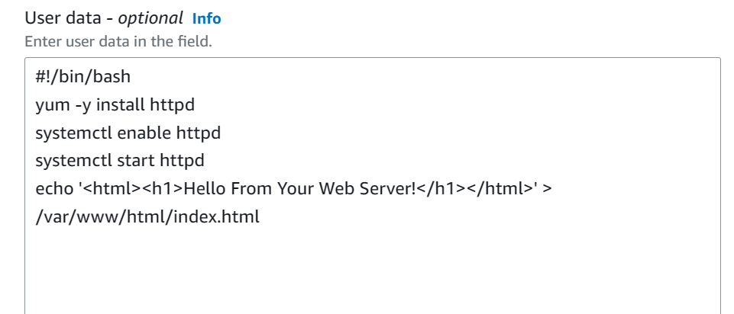

#!/bin/bash

yum -y install httpd

systemctl enable httpd

systemctl start httpd

echo '<html><h1>Hello From Your Web Server!</h1></html>' > /var/www/html/index.html

Step 8: press Launch Instance and View All Instances

Step 9: Wait for the status check to show 2/2 checks passed

Step 10: View Status Checks. They should both be green

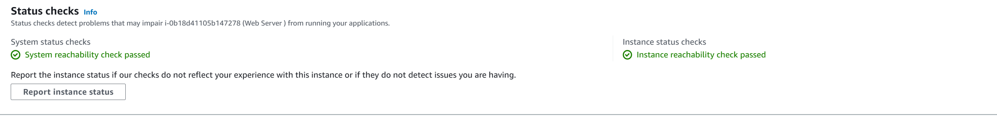

Step 11: got Actions, Monitor and Troubleshoot, and Get System Log

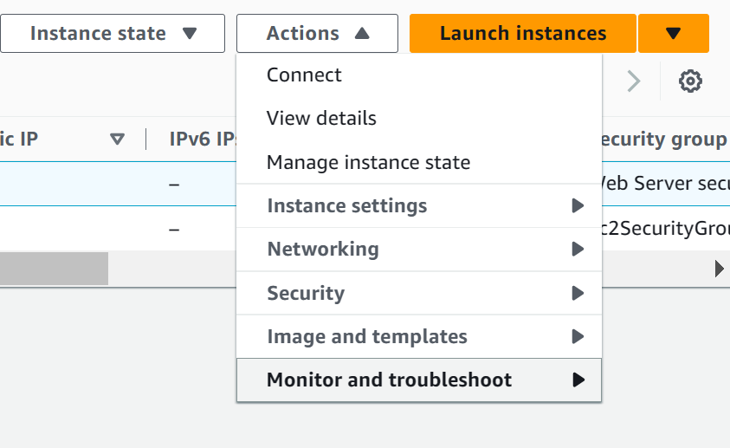

Step 12: You should be able to see the http package installed through the user data

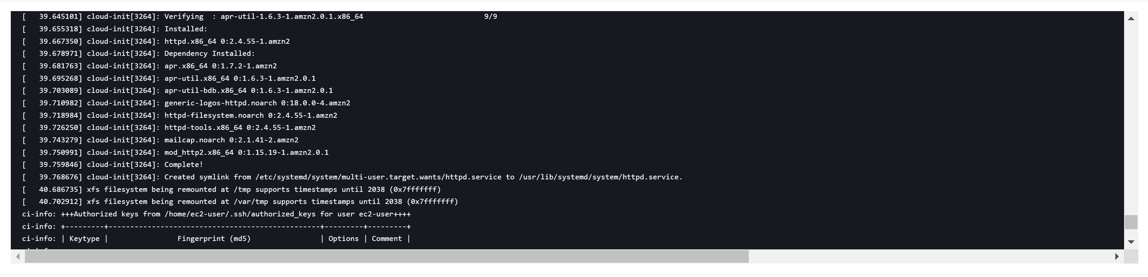

Step 13: go to Actions, Monitor and Troubleshoot, and Get Instance screenshot



Step 14: you should see a screenshot of the EC2 console screen

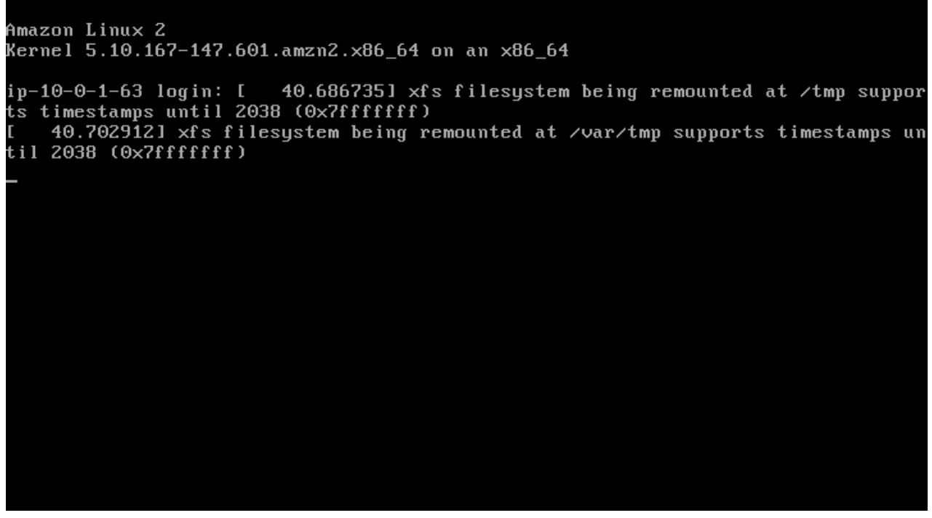

Step 15: go to details and copy the public IP address. If you access it right now, you shouldn’t be able to connect.

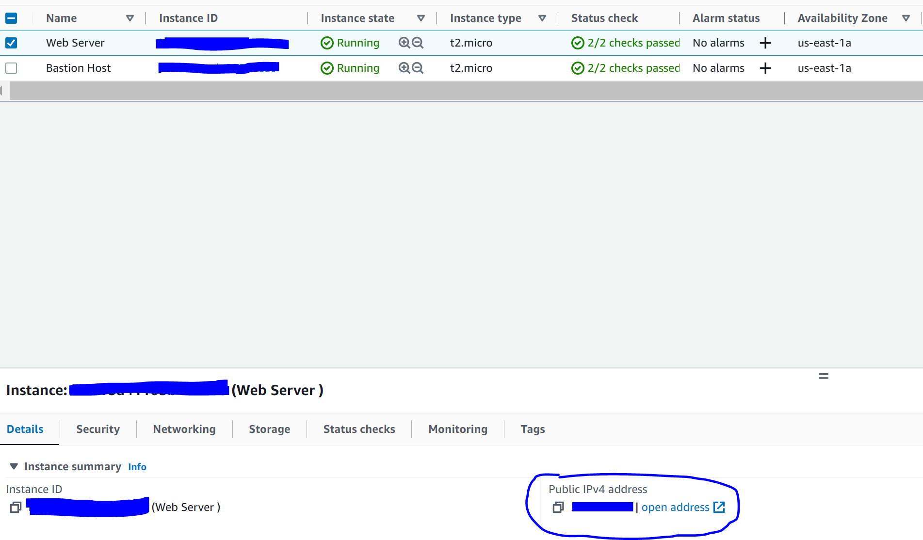

Step 16: got to Security Groups, Web Server Security Group, Inbound rules, and click edit inbound rules.

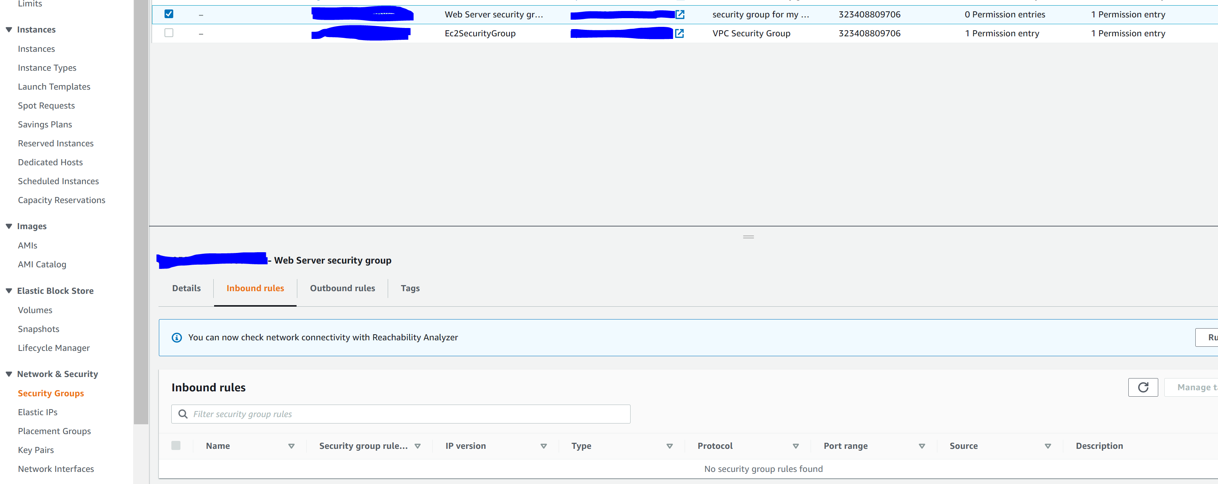

Step 17: configure the following

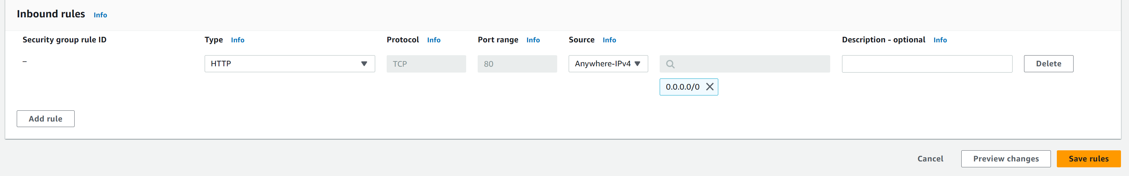

Step 18: visit the public IP address and you should see the following

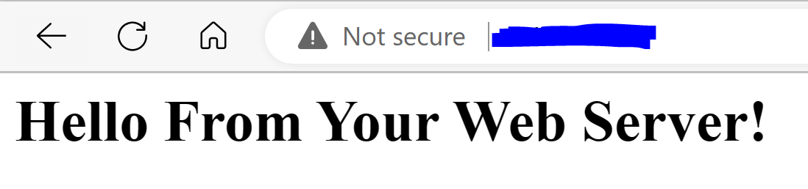

Step 19: go to instances, web server, instance state, and stop the instance. Wait for instance to stop.

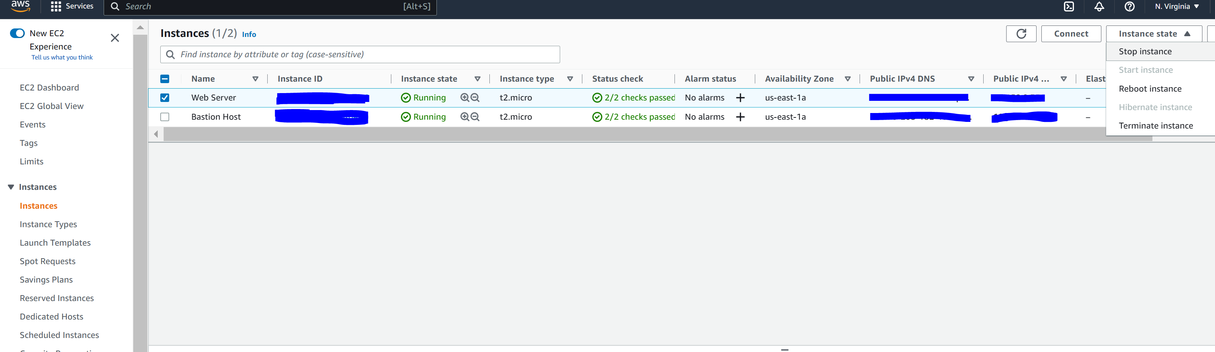

Step 20: go to Actions, Instance settings, and Change Instance Type

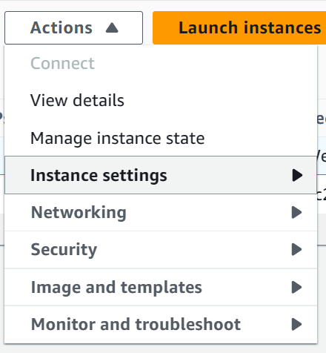

Step 21: configure the following

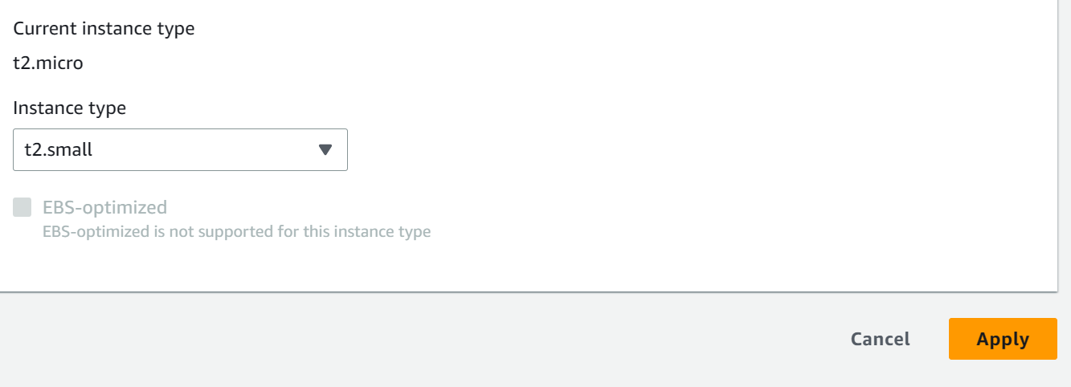

Step 22: Go to Storage and click the Volume ID.

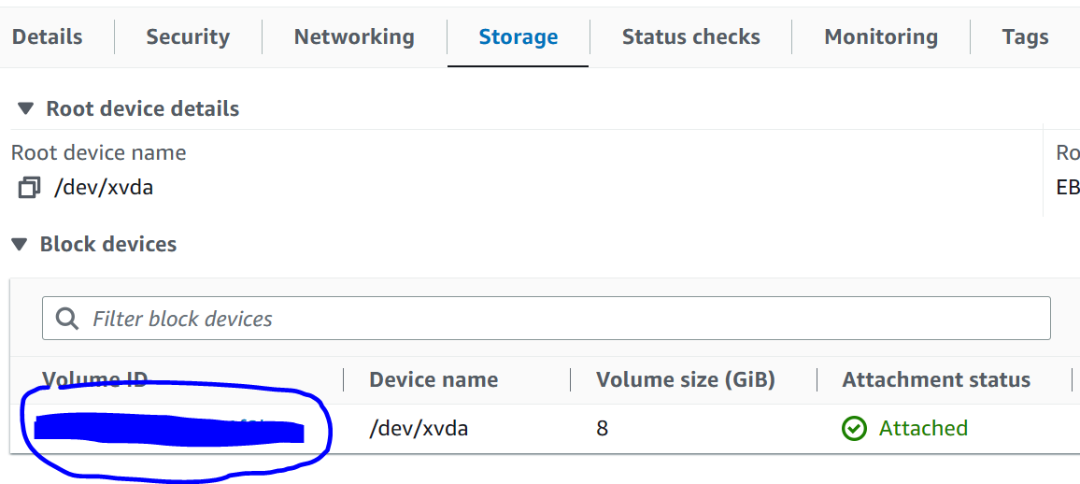

Step 23: Go to Actions, Modify Volume

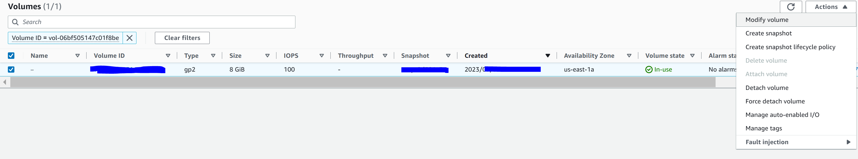

Step 24: configure the following

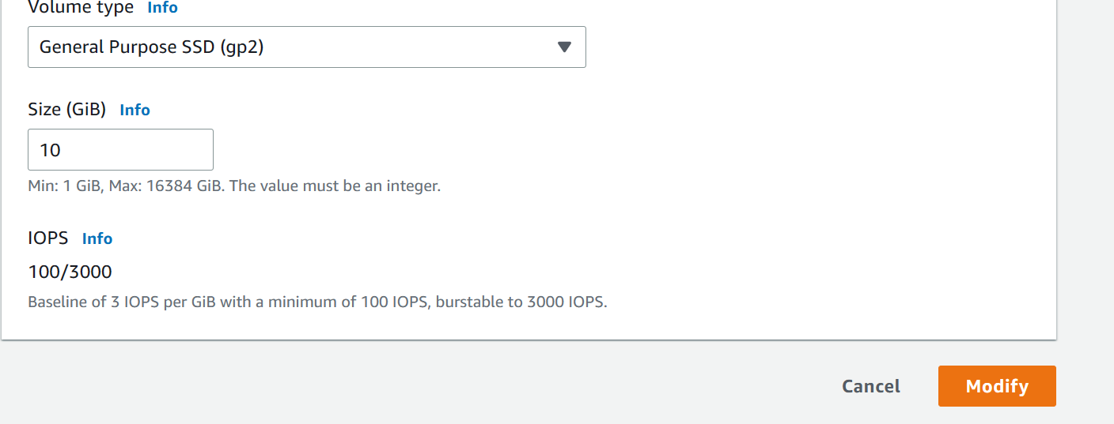

Step 25: Go to Instances, Web Server, Instance State, and Start Instance

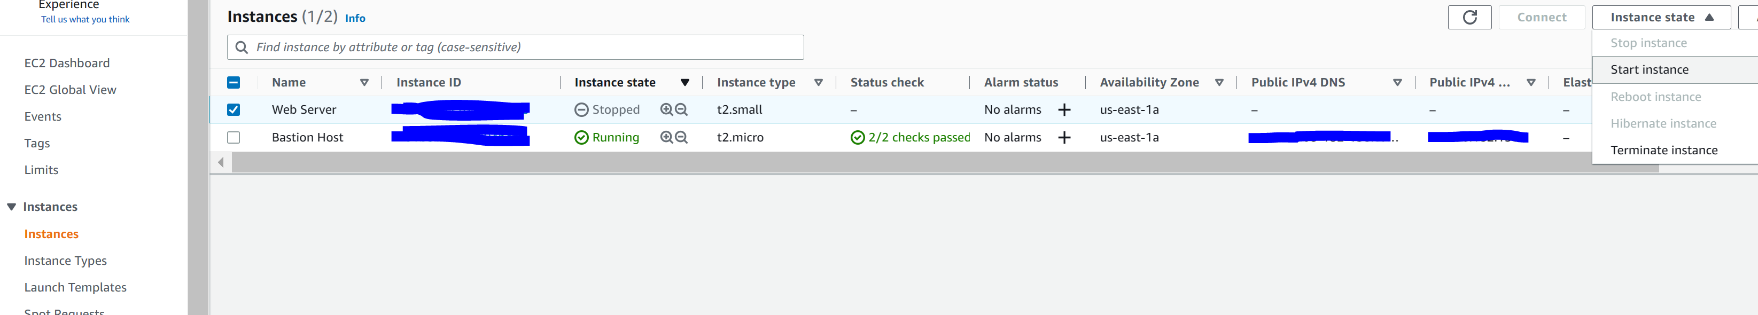

Step 26: we will now terminate (delete) the instance. Go to actions, instance settings, change termination protection

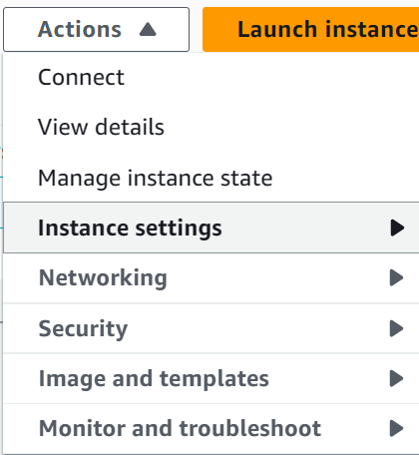

Step 27: configure the following

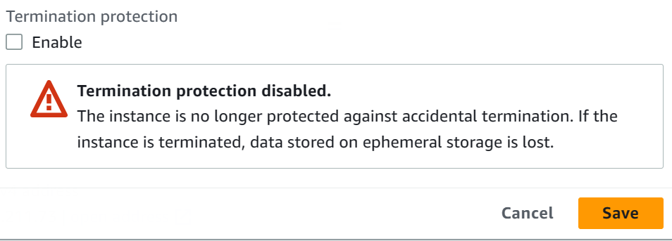

Step 28: Go to Instance State and Terminate Instance.

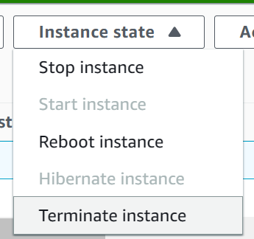

Step 29: Click End Lab

Amazon offers different pricing models for running EC2 instances.

* On-Demand Instances: pay by the hour, no long-term commitments, AWS Free Tier (low cost and flexible. Short amount of time)
* Dedicated Hosts: A physical server with EC2 instance capacity fully dedicated to your use. (use with existing licensing)
* Dedicated Instances: instances that run a VPC on hardware that is dedicated to a single customer.
* Reserved Instances: reserve computing capacity for 1 year or 3-year terms at lower costs (long term workload with predictable use pattern)
* Scheduled Reserved Instances: reserve computing capacity that is always available on a recurring schedule you specify.
* Spot Instances: bid on unused EC2 instance capacity which lower costs. The cost changes based on supply and demand. (Large scale at lower price. If application can tolerate interruptions)

To optimize cost, choose the right size of the server (provision instances and use CloudWatch to view metrics), increase elasticity (stop or hibernate Amazon EBS-backed instances and use automatic scaling), optimal pricing model (leverage the right pricing for your use case), optimize storage choices (change EBS volumes and volume types. Delete unneeded snapshots).

Container services. Containers are method of operating system virtualization. Containers are smaller than VM. Containers support repeatability and consistency.

Docker is a software platform that enables you to build, test and deploy applications quickly. You run containers on Docker. A container has everything a software application needs to run.

Main difference between a container and VM. VM runs directly on hypervisor while containers run on operating systems. This means all containers can run on a single EC2 instance.

Amazon Elastic Container Service simplifies container management. If you want to manage the Amazon ECS cluster that runs the containers, create Amazon ECS cluster backed by Amazon EC2. If you don’t want to manage the Amazon ECS cluster that runs on the containers, create an Amazon ECS cluster backed by AWS Fargate.

Kubernetes is an open-source software for container orchestration. Works with Docker. Since it is popular, a lot of extensions, integrations, and plugins. Automates container provisioning.

Amazon Elastic Kubernetes Service enables you to run Kubernetes on AWS.

Amazon Elastic Container Registry is a fully managed Docker container registry that makes it easy for developers to store, manage, and deploy Docker container images.

AWS Lambda is an approach to computing that allows you to not manage servers. AWS Lambda is an event-driven serverless compute service. A Lambda function is created which is the AWS resource that contains the code you want to run. The Lambda function is then set to be trigger on a schedule or in response to an event. Pay only for compute time consumed. Supports multiple programming languages. Automates administration. Built-in fault tolerance. AWS Lambda can work and respond to different Amazon services.

AWS Elastic Beanstalk is another AWS compute option. Easy way to get web applications up and running. A manage served that automatically hands infrastructure, deployment, load balancing, automatic scaling, health monitoring, analysis, debugging, and logging. No additional charge for Elastic Beanstalk, only pay for the underlying resources. Supports web applications for common platforms.

Conclusion

This lab covers the AWS Cloud Foundations Certification curriculum modules 1-6. The modules include three hands on labs and have also been completed in this lab report. There were no problems with the lab since everything was very telegraphed with no uncertainty.